Kinder Food Finder

Manual for running the app and server

Contents

**A.** **System installation guide** 2

**1.** **Preparation** 2

**1.1.** **Requirements** 2

**1.2.** **Files/Documents sent to the client** 2

**1.3.** **Source Code on GitHub** 2

**2.** **Kinder-Food-Finder Server** 3

**2.1.** **Operating System** 3

**2.2.** **Device** 3

**2.3.** **Software Installation/Preparation** 3

**2.4.** **Steps to Install NodeJS** 3

**2.5.** **Steps to Install ExpressJS** 3

**2.6.** **Steps to Install and Run/Stop/Kill MongoDB** 4

**2.7.** **Steps to Install and Run Robo 3T (Optional)** 4

**2.8.** **Steps to Run the Server** 5

**3.** **Manual for Kinder-Food-Finder Application** 11

**3.1.** **Operating System** 11

**3.2.** **Device** 11

**3.3.** **Software Installation/Preparation** 11

**3.4.** **Steps to Open Developer Mode in Your Android Device and Enable USB Debugging** 11

**3.5.** **Steps to Close Developer Mode If Not Needed Any More** 12

**3.6.** **Steps to Setup Virtual Device in Android Studio If No Android Device (Optional)** 13

**3.7.** **Steps to Generate APK File of Application (Optional)** 17

**3.8.** **Steps to Find Out Your IP Address in Your Laptop/Desktop Which Will Run Server** 20

**3.9.** **Steps to Run Our Application and Install It in Your Android Device/Virtual Device** 20

**B.** **Guidance on operating the server-side** 24

**1.** **Login to the Server-side** 25

**2.** **Import/ Insert data** 28

**3.** **Update/ delete brand data** 31

**4.** **Update/ delete store data** 34

**5.** **Report** 39

**6.** **Publish** 40

**7.** **Statistics** 40

# **System installation guide**

## **Preparation**

## **Requirements**

* Laptop/desktop (Mac/MacBook recommended)
* Android mobile device
* Source code of both app and server
* A script to install essential libraries before server setup
* Sample CSV file for brand data (correct format required)

## **Files/Documents sent to the client**

* A folder called “**KinderFoodFinder**” that consists of source code for application
* A folder called “**KFF_Server**” that consists of source code for server
* A sample csv file called “**products.csv**”
* A script called “**installExpress**”
* A manual for app and server called “**Kinder Food Finder manual**”

## **Source Code on GitHub**

* As the source code could be updated later, you will need to download the newer version on our GitHub: <https://github.com/WolfeLeee/comp5703project>

## **Kinder-Food-Finder Server**

## **Operating System**

* Laptop/desktop: macOS

## **Device**

* Mac/MacBook

## **Software Installation/Preparation**

* **WebStorm** installed in the laptop/desktop (<https://www.jetbrains.com/webstorm/> and free 30-day trial or as Sydney Uni student, you can apply a student account from <https://www.jetbrains.com/shop/eform/students> so you are free to use it until you graduate)
* (Optional) **Eclipse** or **IntelliJ** can replace WebStorm to run the server code
* **NodeJS** installed in your laptop/desktop
* **ExpressJS** installed in your laptop/desktop
* **MongoDB** used as database installed in your laptop/desktop
* (Optional) **Robo 3T** installed in your laptop/desktop so you can see data directly in MongoDB

## **Steps to Install NodeJS**

* Go to the website: <https://nodejs.org/en/download/>
* Download the **macOS Installer** (.pkg)
* Run the installer you have downloaded
* Keep clicking on Next and accept the License Agreement and done

## **Steps to Install ExpressJS**

* Go to the website and install **Homebrew** first: <https://brew.sh/>
* Open the **terminal** in your laptop/desktop
* Type the command brew install npm and enter to **install “npm”** first by Homebrew
* Type the command sh ScriptName and enter to run the script, this will install all the essential elements for Express. The “**ScriptName**” should be the script sent to you at the beginning called “installExpress”. You can simply type “sh ” and then drag the script to the terminal so that it will give the absolute path for the script
* During running the script, it will ask your username and password for the laptop/desktop to give the permission to install them
* After the installation completed, it is done

## **Steps to Install and Run/Stop/Kill MongoDB**

* Go to the website: <https://treehouse.github.io/installation-guides/mac/mongo-mac.html>
* Follow the instructions (recommended to install MongoDB by Homebrew)
* To run the MongoDB, simply type the command mongod in your **terminal** and enter
* To stop the MongoDB, simply hit **Ctrl-C** (Don’t just close the terminal, it won’t stop)
* If you closed the terminal already, then you will need to type the command **killall -15 mongod** and enter to kill the MongoDB service

## **Steps to Install and Run Robo 3T (Optional)**

* Go to the website: <https://robomongo.org/download>
* Select the button **“Download Robo 3T”**
* Select the Mac and download the installer (.dmg)
* Double click on the installer to run the installation
* After the installation completed, run **Robo 3T**
* Create a connection to local host
* **Type**: Direct Connection; **Name**: can be anything; **Address:** localhost : 27017
* Click on Save and choose the connection created by you
* Click on Connect
* Now you will see a connection called the name you defined while creating on the left-hand side and double click on it
* There will be a database called **“kff”** after the server runs
* You will see all the collections that server has under the database

## **Steps to Run the Server**

* Complete the installations for **NodeJS**, **ExpressJS**, and **MongoDB;**
* Install **WebStorm** (Other options: Eclipse or IntelliJ) and open it;
* Select “**Open**” (Refer to Figure 1) and open the folder called “**KFF_Server**” sent to you;
* After then, click on “**Add Configuration…**” at the top-right side (Refer to Figure 2);
* Click on **add (+)** button at the top-left side in the pop-up window (Refer to Figure 3);
* Select “**Node.js**” and it will open the configuration in the right side (Refer to Figure 4 and 5);
* In the “**JavaScript file**”, type “**app.js**” and click on “**OK**” (Refer to Figure 6);
* Now you will see the **arrow icon with green colour** at the top-right side that you are ready to run the code (Refer to Figure 7)
* Before running the server code, make sure **MongoDB** has been run (See the tutorial from above)
* If running **successfully**, it will show you the message “**KFF app listening on port 3000!**” and “**mongodb connected!**” (Refer to Figure 8)
* Now you can prepare and run application by following the **manual for application** in the next page

**Note**: If you are using **Eclipse** or **IntelliJ**, then it is the same that you add the configuration for “**Node.js**”.

**\*\*\*Note**: If you want to **change the port** to whatever you like as **the default port setup is 3000**, then you can go to **app.js** in the folder of “**KFF_Server**” sent to you and change the port to yours as **Figure 21** below.

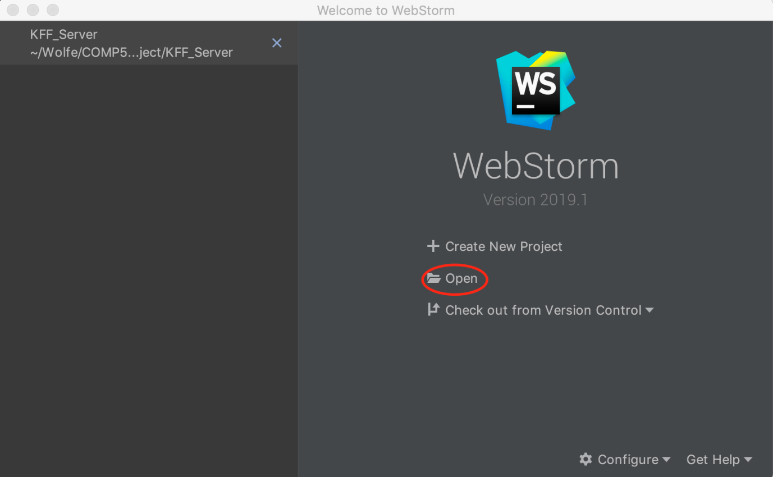

Figure 1. Open the new project

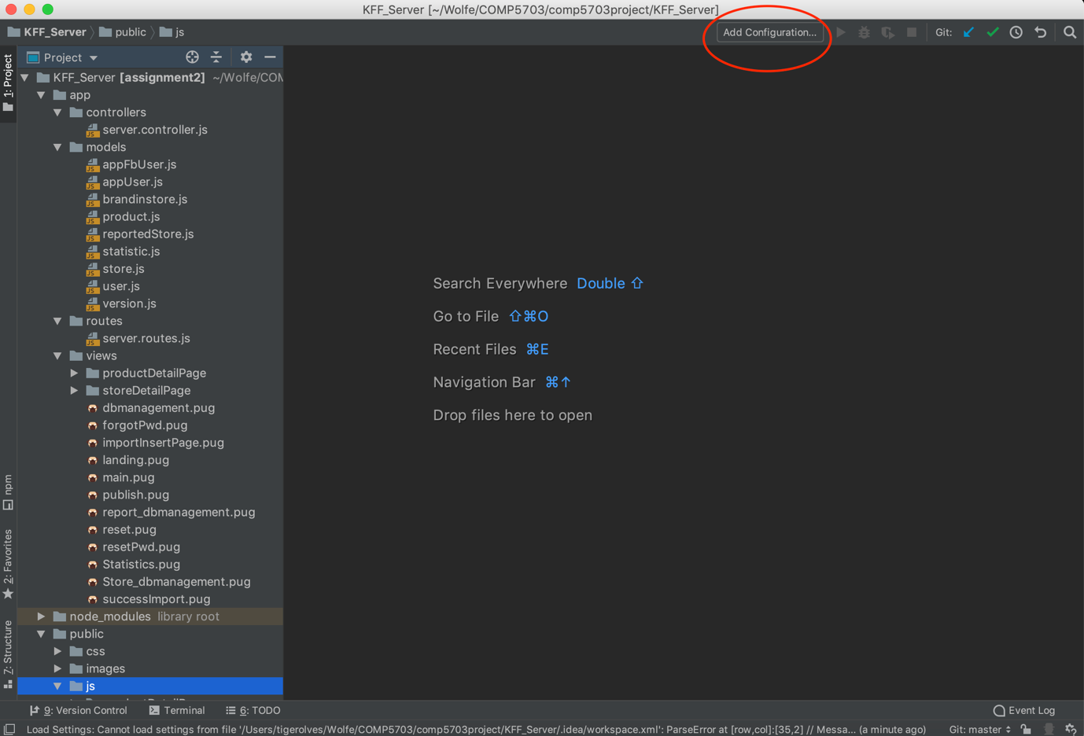

Figure 2. Add configuration

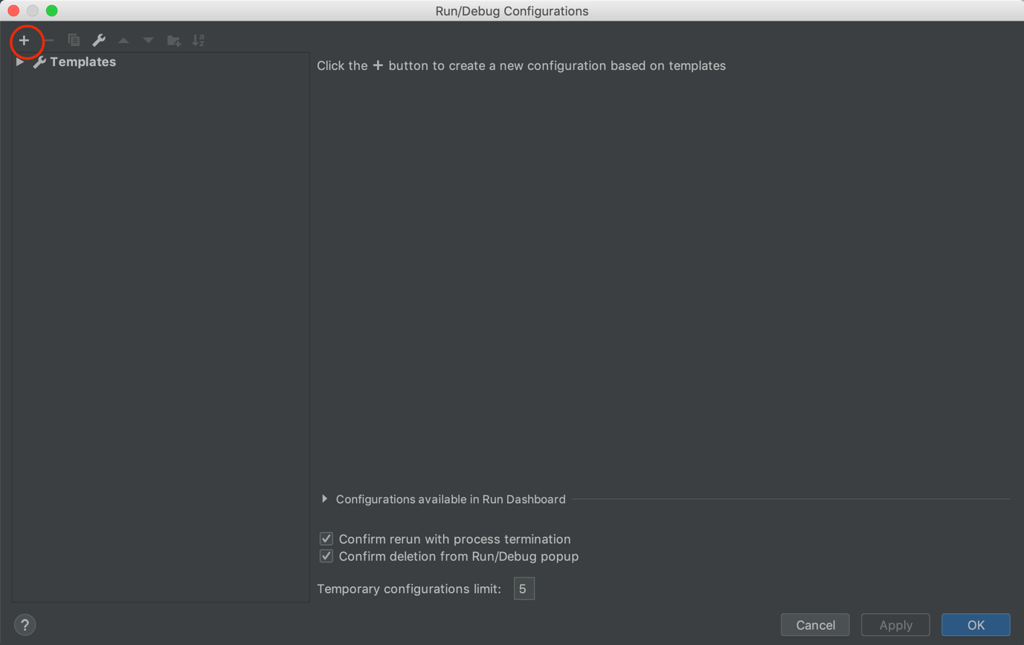

Figure 3. Add (+) button

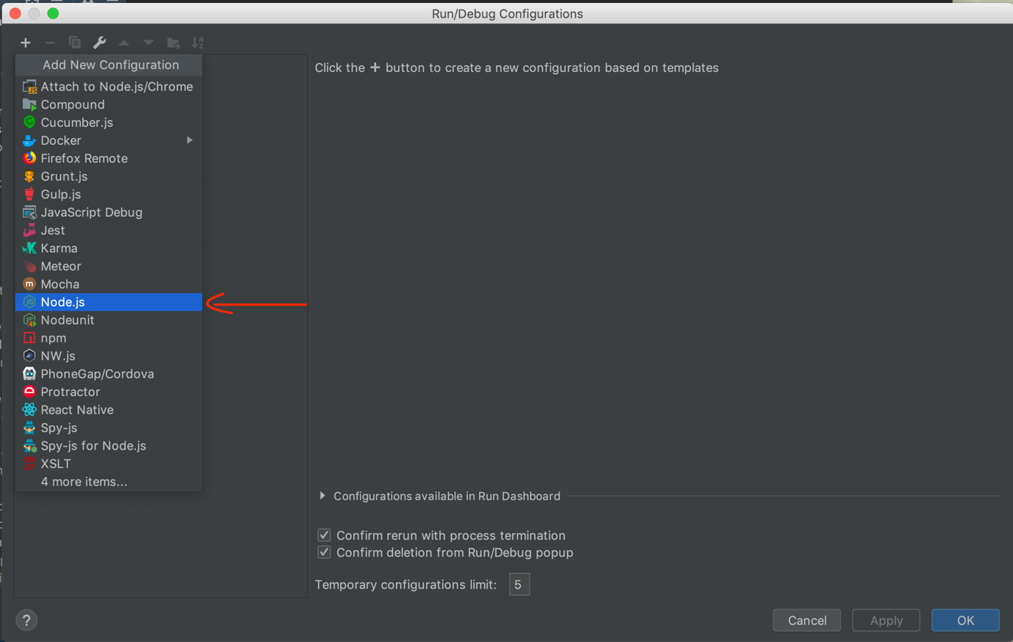

Figure 4. Select Node.js for configuration

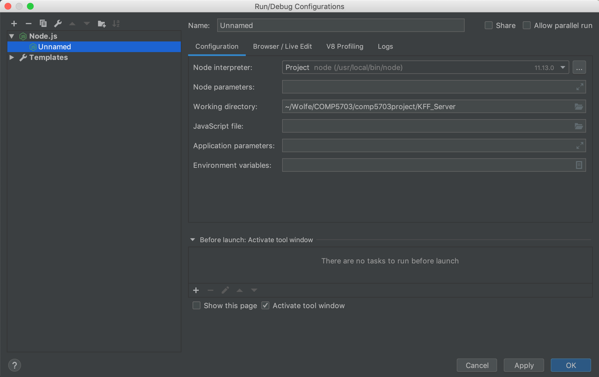

Figure 5. Configuration setup

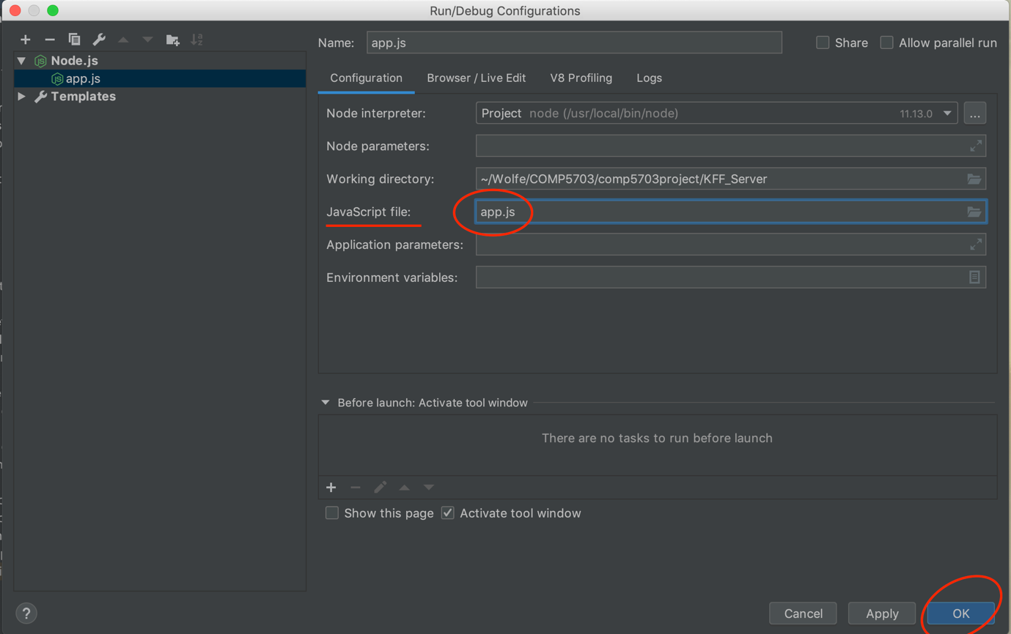

Figure 6. The JavaScript file to run the code

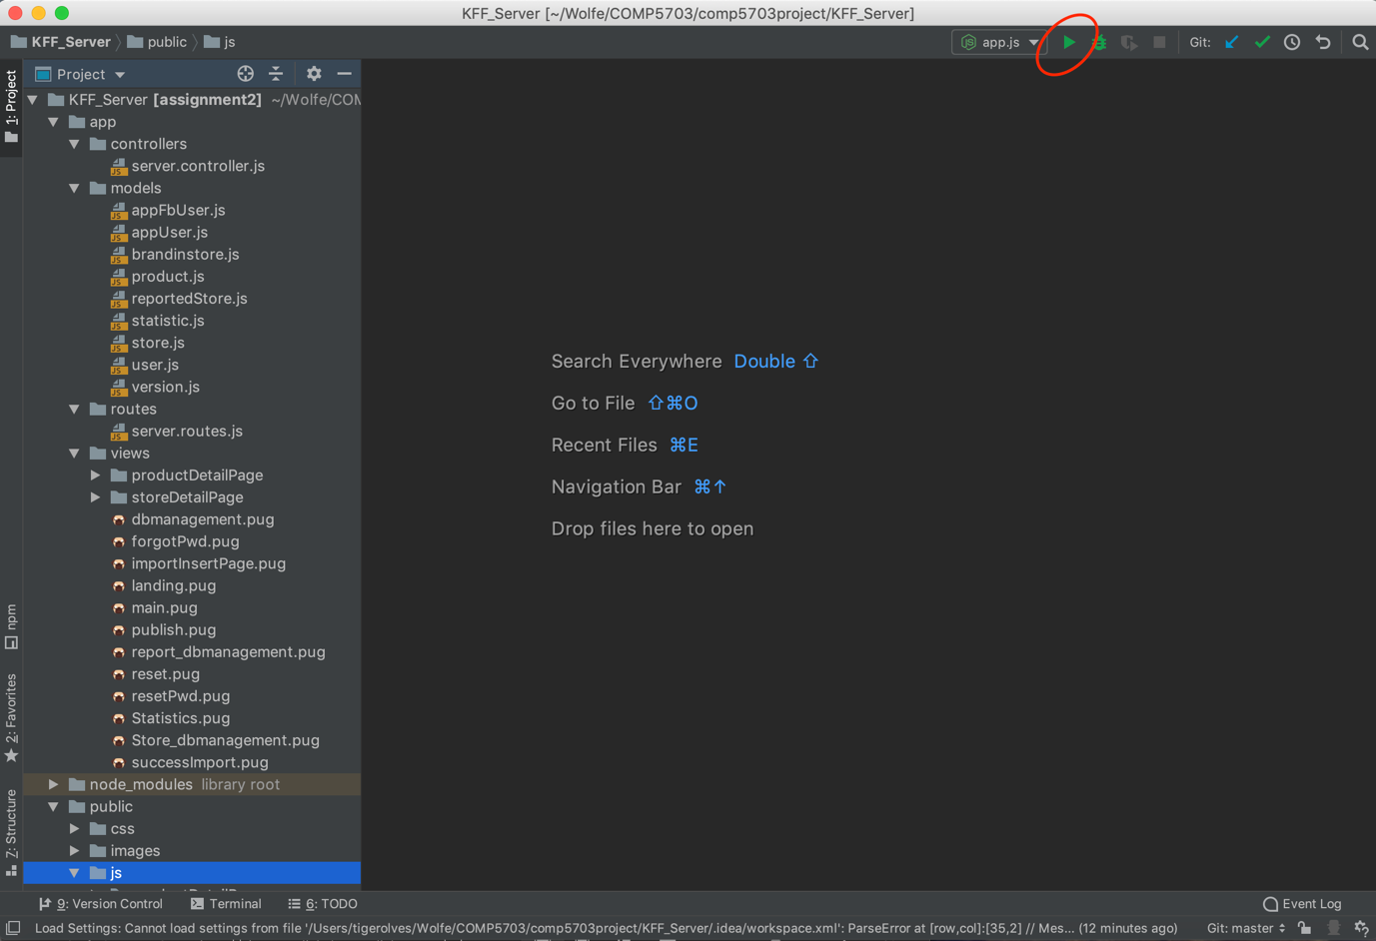

Figure 7. Run the code

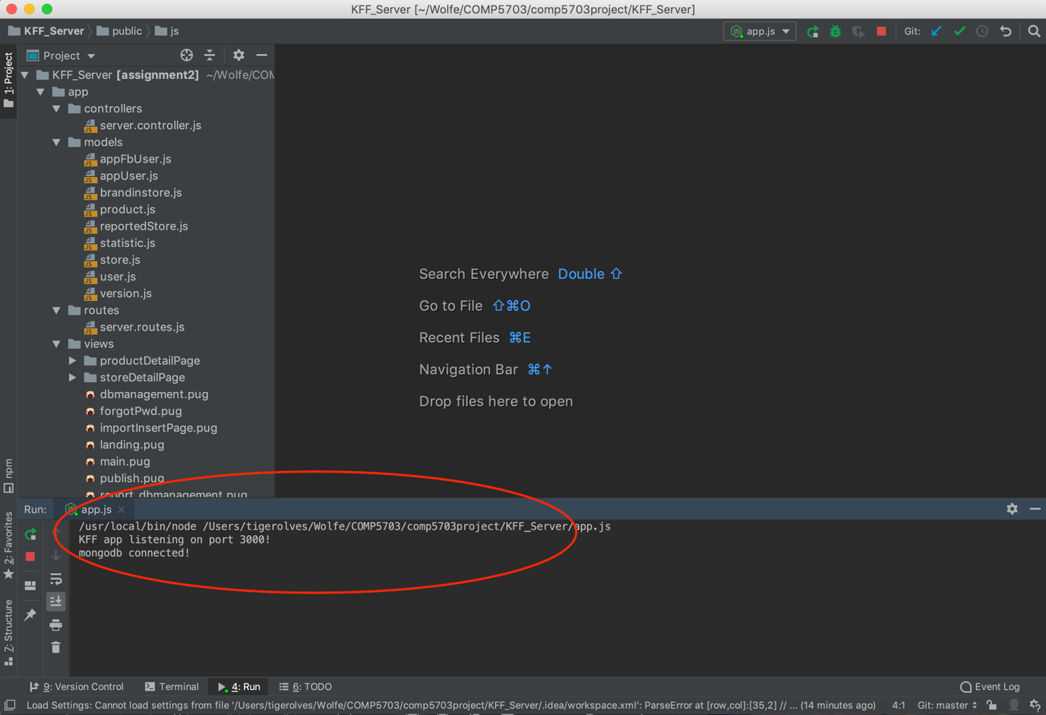

Figure 8. Successfully running message

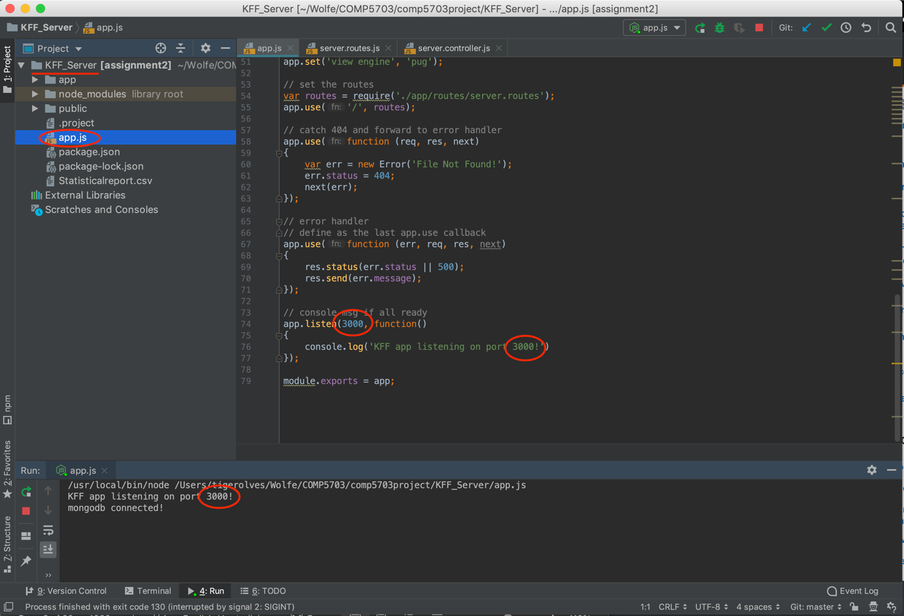

Figure 9. Change the port of server from the default port 3000

## **Manual for Kinder-Food-Finder Application**

## **Operating System**

* Mobile device: Android;
* Laptop/desktop: macOS.

## **Device**

* Any android device (e.g. Nexus 6);
* Mac/MacBook.

## **Software Installation/Preparation**

* **Android Studio** installed in the laptop/desktop (<https://developer.android.com/studio>);
* Android device required to open **developer mode;**
* (Optional) Using **Android Virtual Device** in Android Studio to run application if you don’t have any Android device.

## **Steps to Open Developer Mode in Your Android Device and Enable USB Debugging**

* Go to the **Settings** in your device;
* Scroll down to find the **About/About Phone** and click on it;
* Scroll down again to find **Build number** (Refer to Figure 10);
* There are **few popular devices** and their **location of Build number** (Refer to Figure 11);
* Tap on it **7 times** (After a few taps, you may see a small pop-up alert telling you that “You are now X steps away from being a developer”);
* After the seventh tap, a message will appear telling you that “You are now a developer!”;
* Go back to the **first page of Settings;**
* Scroll down to find the **Developer options** and click on it;
* Scroll down to find **USB Debugging** under **Debugging tag** and turn it on.

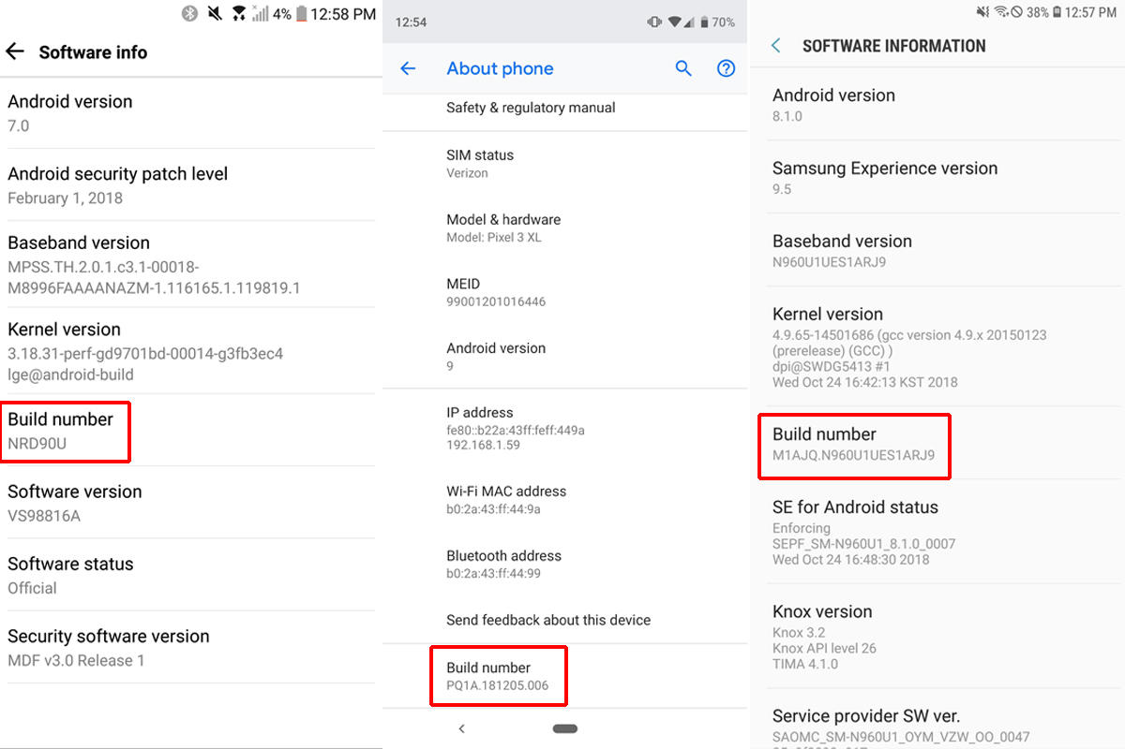

Figure 10. The location of Build number

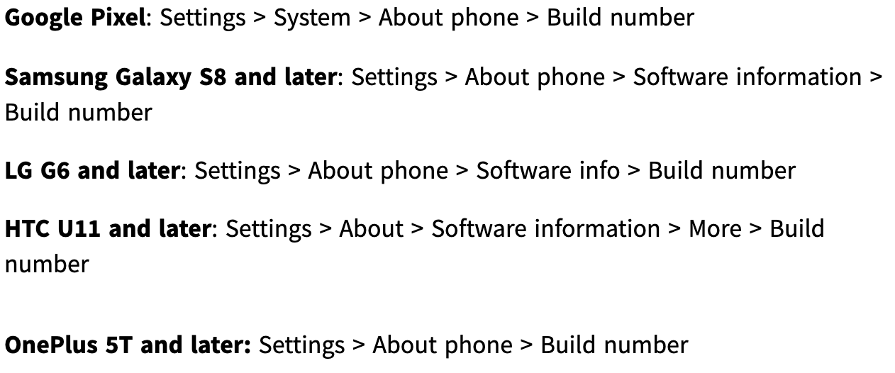

Figure 11. How to find Build number in few popular devices

## **Steps to Close Developer Mode If Not Needed Any More**

* Go to the **Settings** in your device
* Scroll down to find the **Developer options** and click on it
* After you get in, you will see **an on/off toggle** at the top of screen
* Switch it to **Off**

## **Steps to Setup Virtual Device in Android Studio If No Android Device (Optional)**

* Open **Android Studio** in your laptop/desktop after you installed it;
* Select “**Import project (Gradle, Eclipse ADT, etc.)**” (Refer to Figure 12);
* Choose the **folder** called “**KinderFoodFinder**” sent to you;
* Waiting for it building up and synced successfully (Ignore the warning at the bottom-right side) (Refer to Figure 13);
* On the top-right side, there is an icon called “**AVD Manager**” (Refer to Figure 14);
* Click on it and a window will be opened called “**Android Virtual Device Manager**”;
* Click on the button called “**Create Virtual Device…**” at the bottom-left side (Refer to Figure 15);
* Select **Phone** for category and Choose **Nexus 6** (recommended) for device (Refer to Figure 16);
* After clicking on **Next**, select **Pie** for system image (Download it if you do not have the file) and click on **Next** (Refer to Figure 17);
* In verify configuration page, you can define the **name** for this Android Virtual Device and then select **Portrait** view for Start-up orientation (Refer to Figure 18);
* Click on Finish.

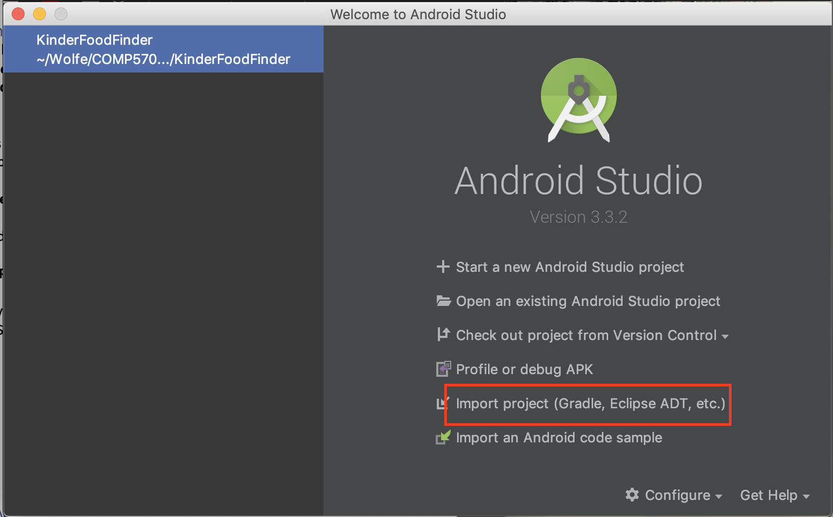

Figure 12. Open Android Studio and import project

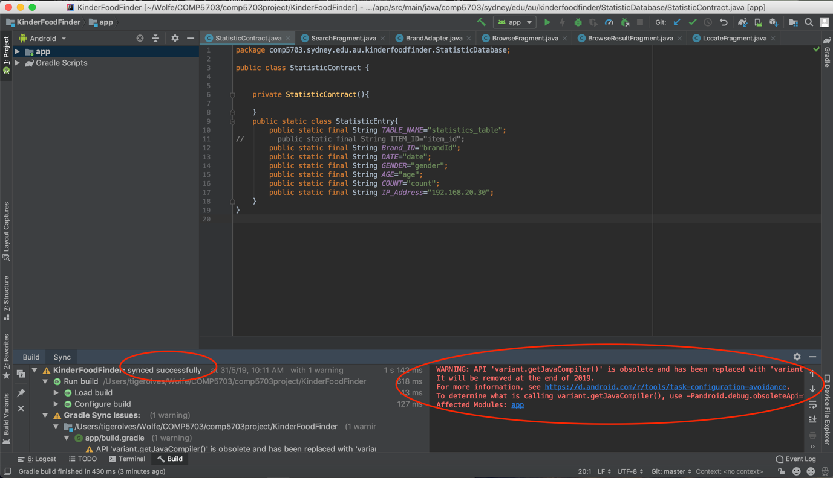

Figure 13. Successfully build up and warning message

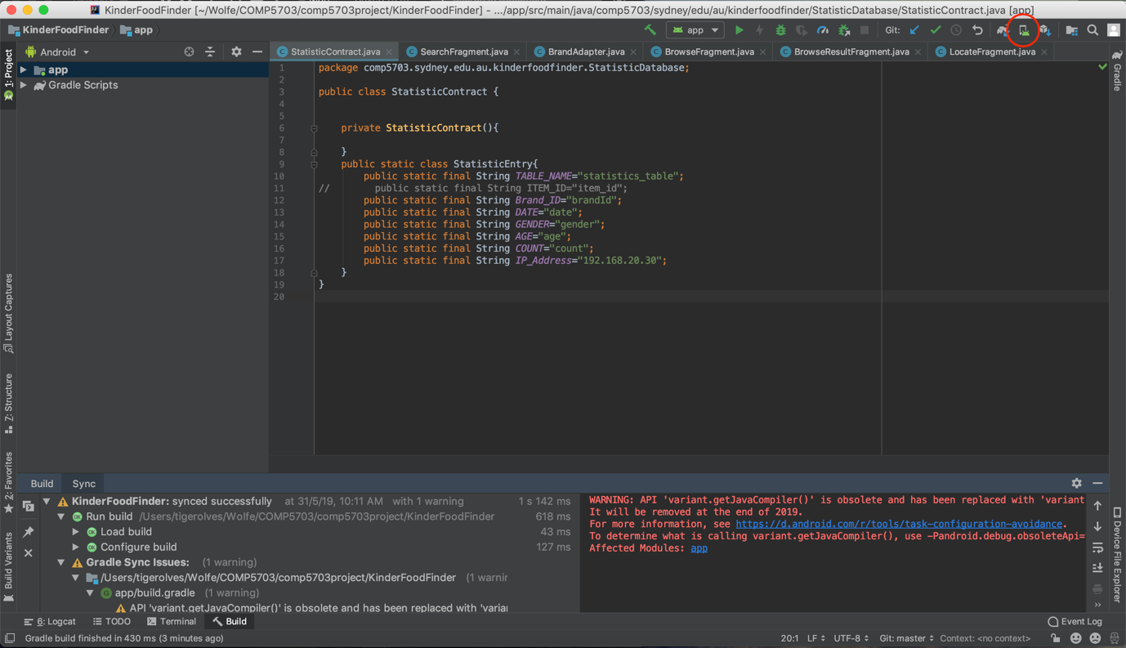

Figure 14. Icon for AVD Manager

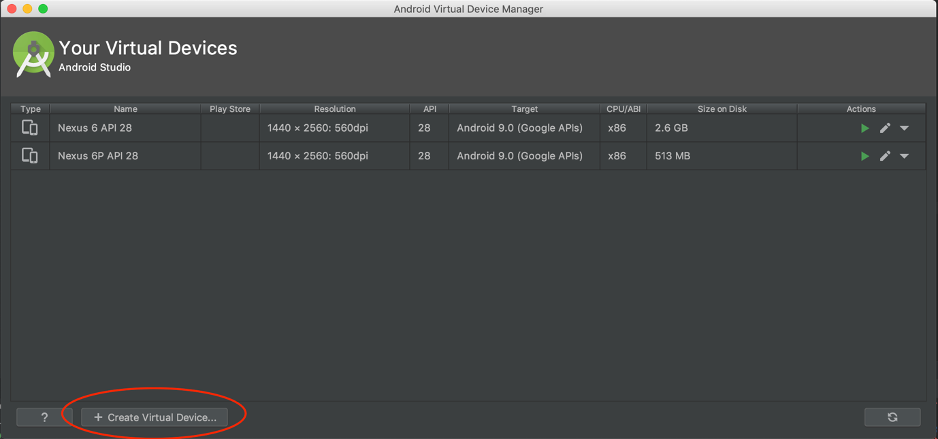

Figure 15. Create new virtual device

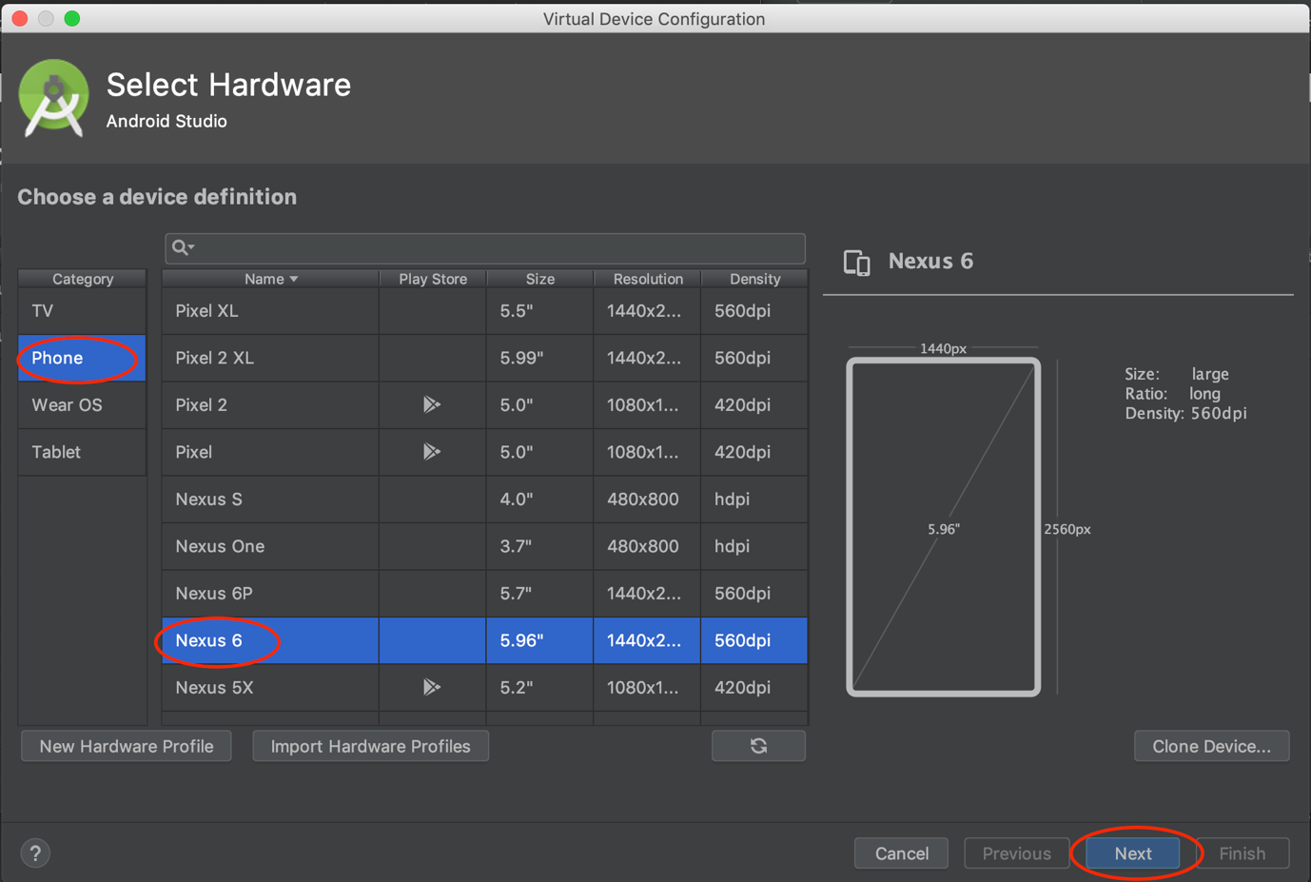

Figure 16. Select category and device

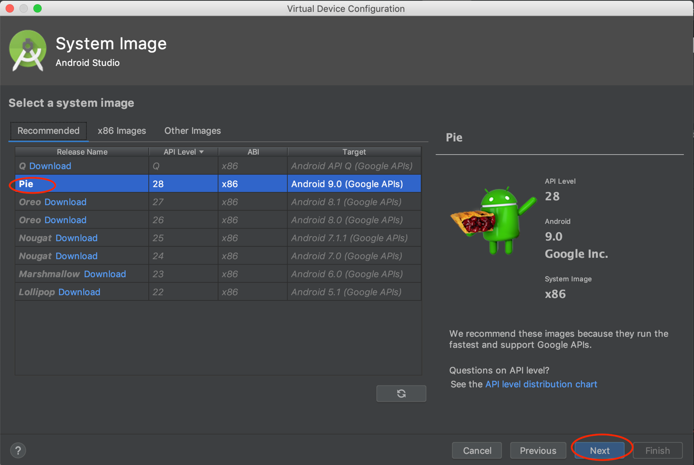

Figure 17. Select a system image

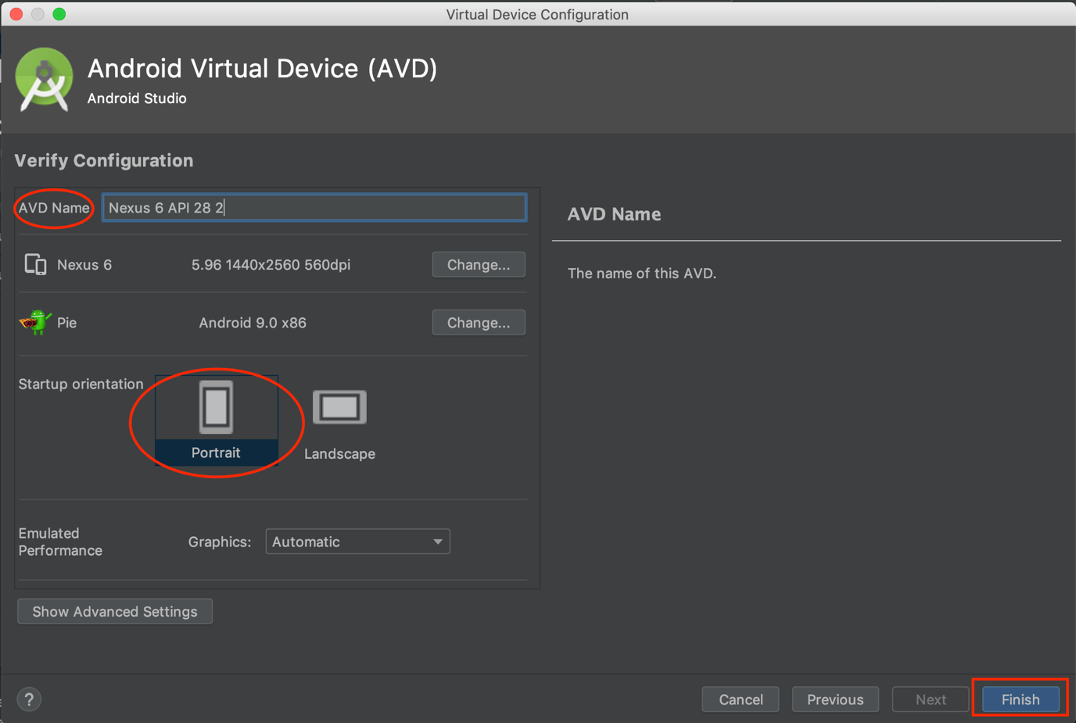

Figure 18. Define the name and start-up orientation

## **Steps to Generate APK File of Application (Optional)**

* Open **Android Studio** in your laptop/desktop after you installed it
* Select “**Import project (Gradle, Eclipse ADT, etc.)**” (Refer to Figure 12 above)
* Choose the **folder** called “**KinderFoodFinder**” sent to you
* Waiting for it building up and synced successfully (Ignore the warning at the bottom-right side) (Refer to Figure 13 above)
* On the top action bar, go through Build -> Build Bundle(s) / APK(s) -> Build APK(s) (Refer to Figure 19)
* Wait until the APK build up being successful (Refer to Figure 20)
* Click on “Event Log” at the bottom-right corner and click on “locate” (Refer to Figure 21)
* It will open the located folder that generates the APK file (Refer to Figure 22)

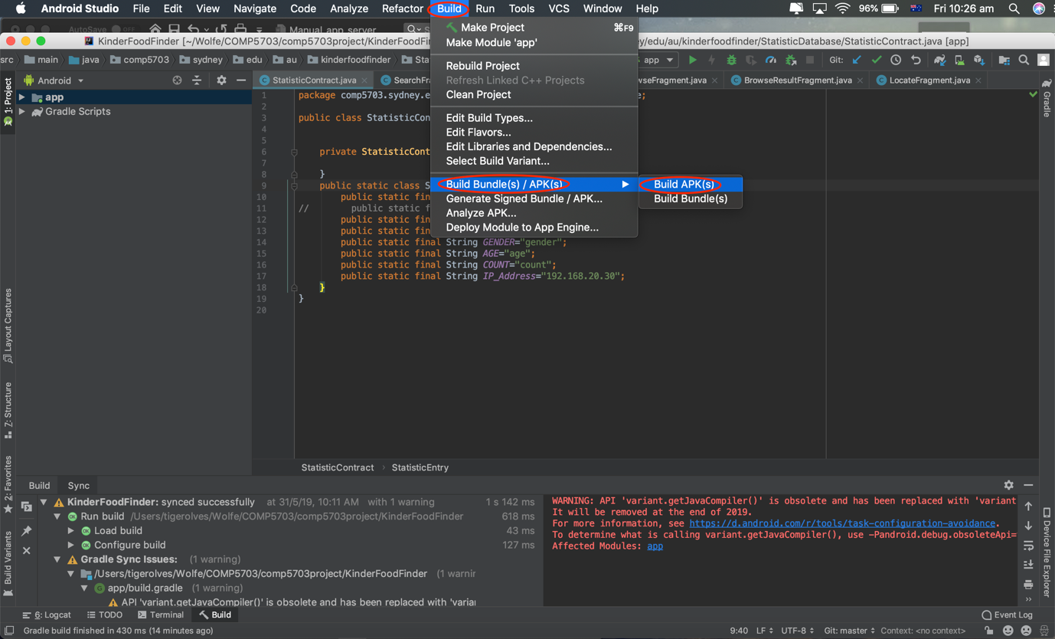

Figure 19. Build-up APK file for application

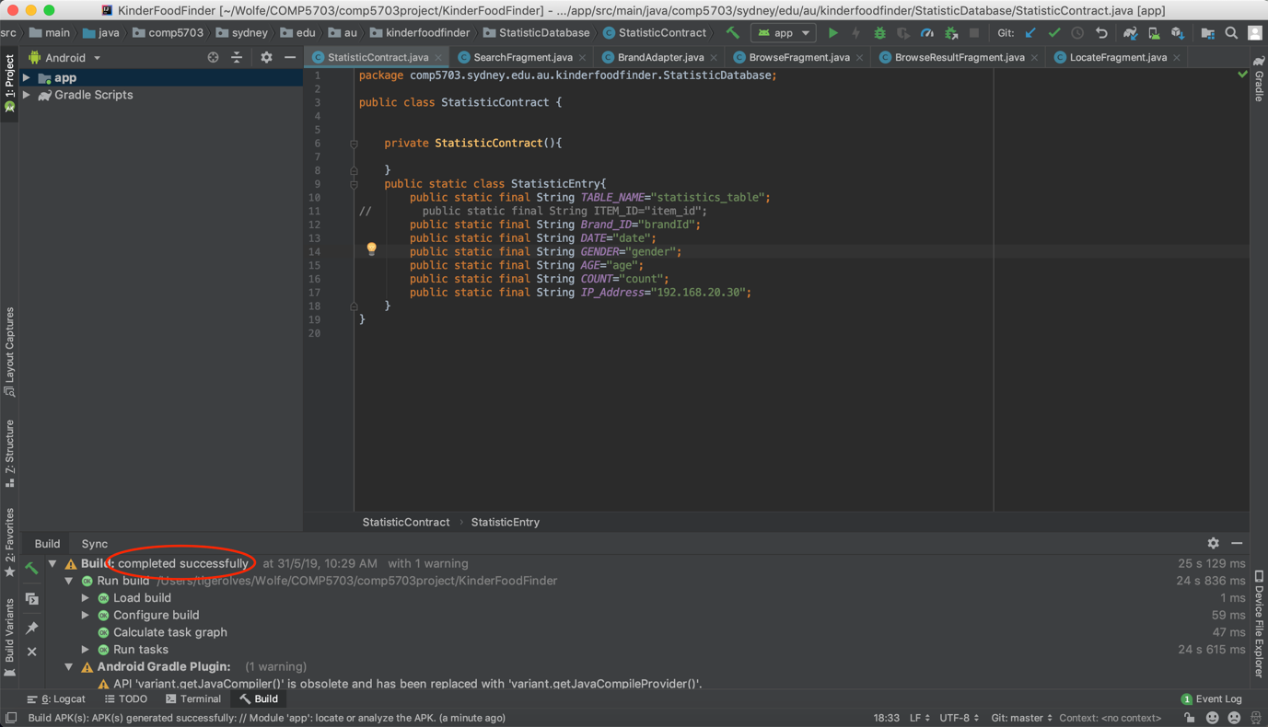

Figure 20. Build-up APK file successfully

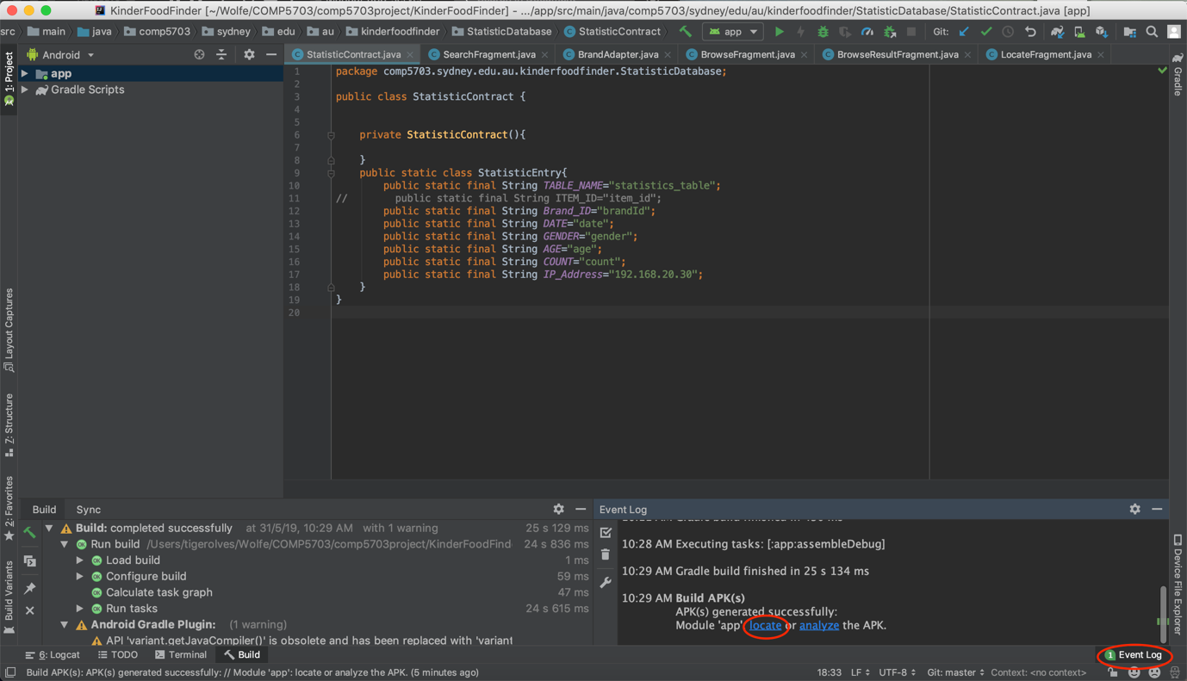

Figure 21. Event Log to see the location of APK file

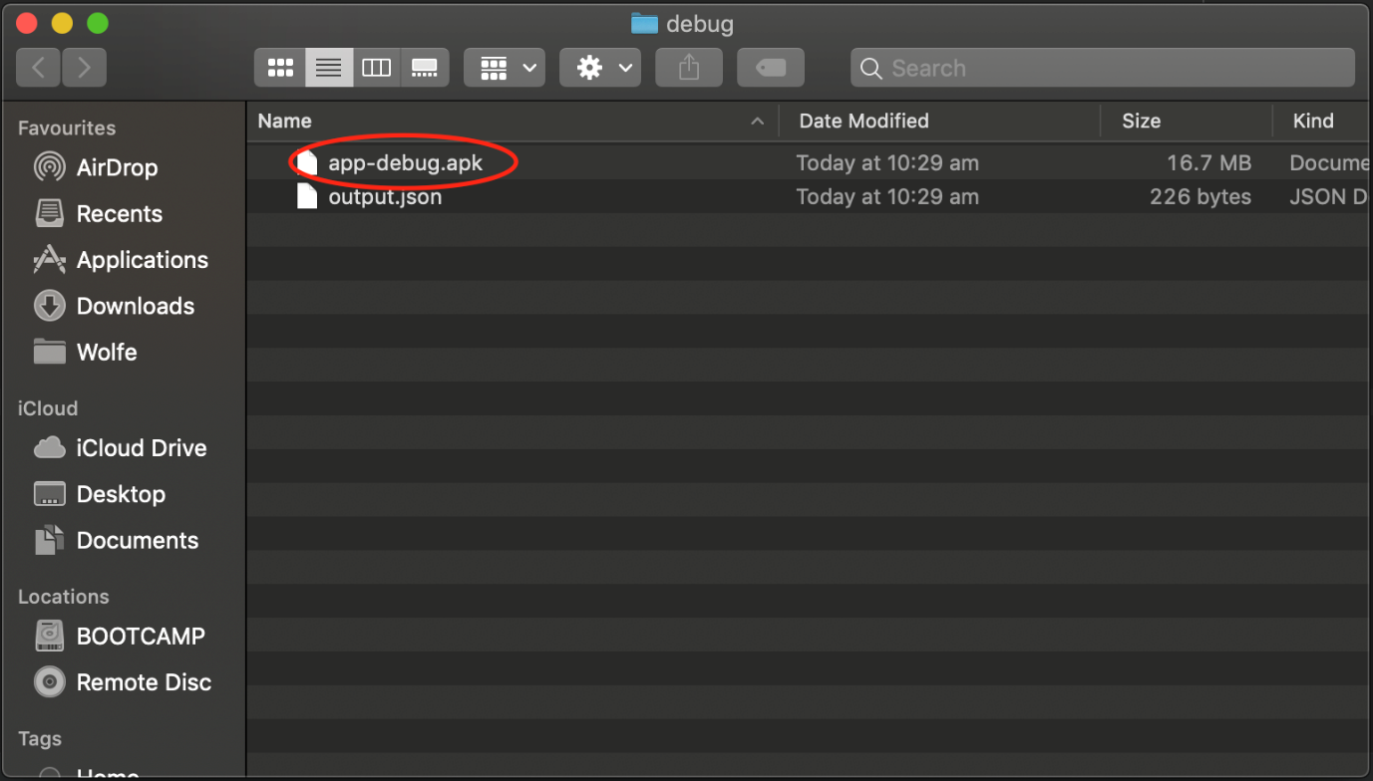

Figure 22. APK file

## **Steps to Find Out Your IP Address in Your Laptop/Desktop Which Will Run Server**

* Open the **terminal** in your Mac/MacBook
* Type the command **ipconfig getifaddr en1** and enter
* It will show the **IP address** such as 100.101.86.121

## **Steps to Run Our Application and Install It in Your Android Device/Virtual Device**

* Open **Android Studio** in your laptop/desktop after you installed it
* Select “**Import project (Gradle, Eclipse ADT, etc.)**” (Refer to Figure 12)
* Choose the folder called “**KinderFoodFinder**” sent to you
* Waiting for it building up and synced successfully (Ignore the warning at the bottom-right side) (Refer to Figure 13)
* After building up successfully, you will see **all the related folders and files** included in the folder “**KinderFoodFinder**” sent to you on the left-hand side (Refer to Figure 23)
* Go through the folders: **app -> java -> comp5703.sydney.edu.au -> kinderfoodfinder -> StatisticDatabase** and double click on the file called “**StatisticContract.java**” (Refer to Figure 24)
* You will see the code on the right-hand side and in the last line, there is a variable called “**IP_Address**” (Refer to Figure 25)
* **Change the value to your IP address** which is found from the tutorial above that teaches you how to find IP address in your computer (Refer to Figure 26)
* Now connect your android device to your computer and the device will pop-up a window to ask you if enable USB debugging or not, then click on “Yes”
* Back to Android Studio, click on the arrow icon with green colour called “Run app” at the top bar (Refer to Figure 27)
* In the pop-up window, you should see your Android device appearing under **Connected Devices** (Refer to Figure 28)
* (Optional) If you don’t have any Android device and choose to use virtual device which is setup from the tutorial above, then you will see the virtual device you created appearing under **Available Virtual Devices** (Refer to Figure 29)
* Select the Android device/Virtual device and click on “OK”
* After setup and installing, the application will be opened automatically in the device

**Note**: Make sure your laptop/desktop running the server and Android device are in the same WIFI network since now they are running locally

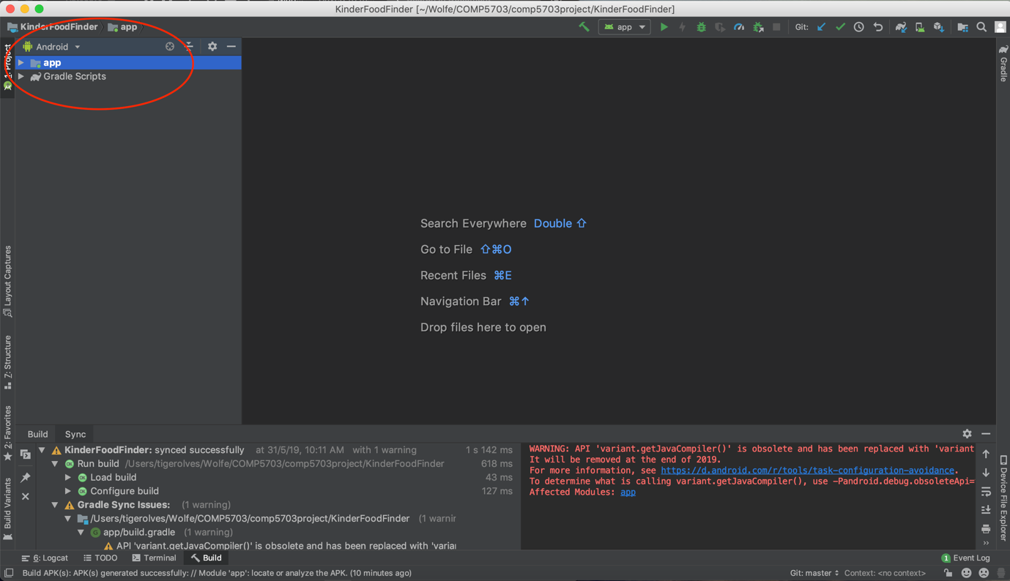

Figure 23. All related folders and files

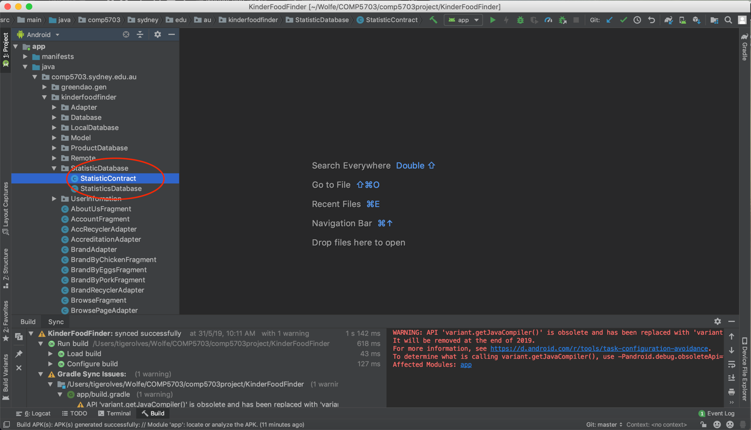

Figure 24. Go to StatisticContract class

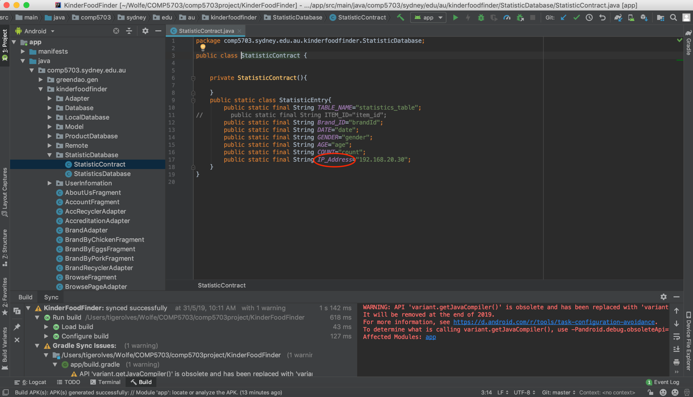

Figure 25. Variable of IP Address

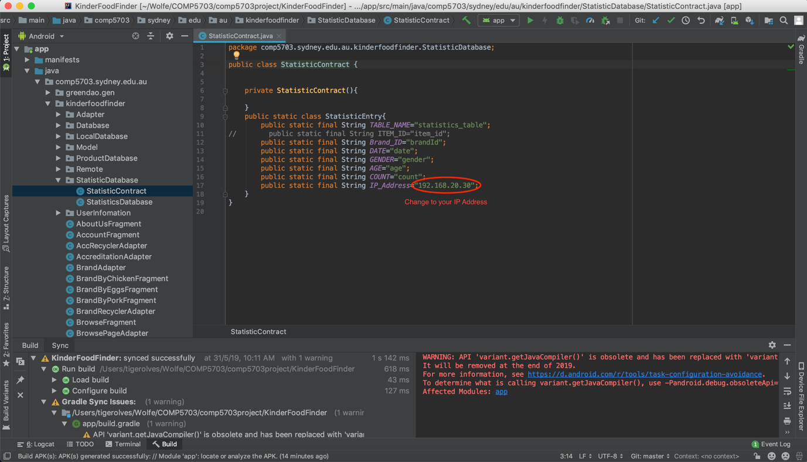

Figure 26. Change IP Address to yours

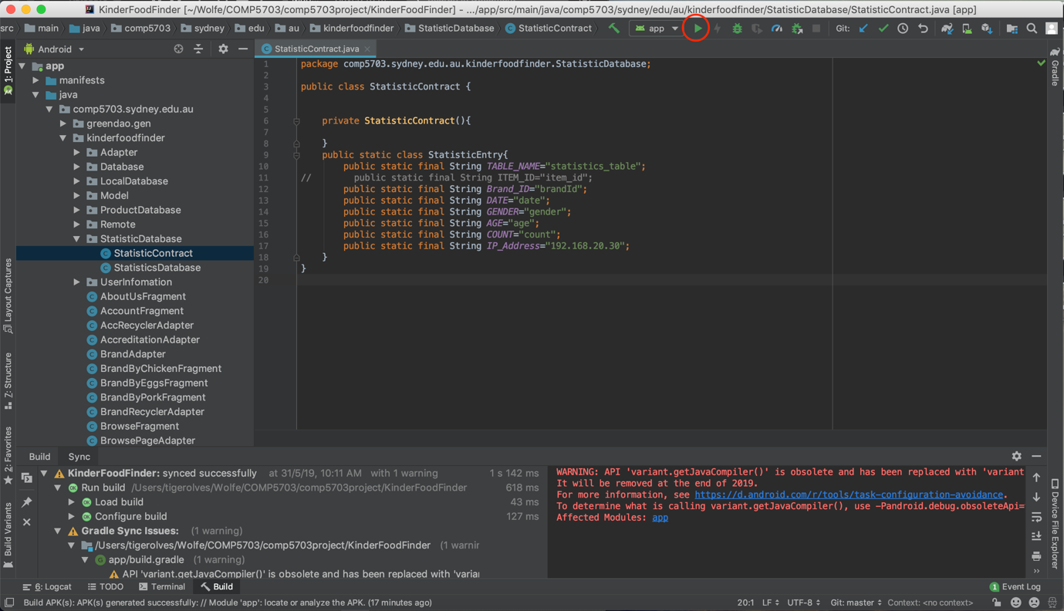

Figure 27. Run the code

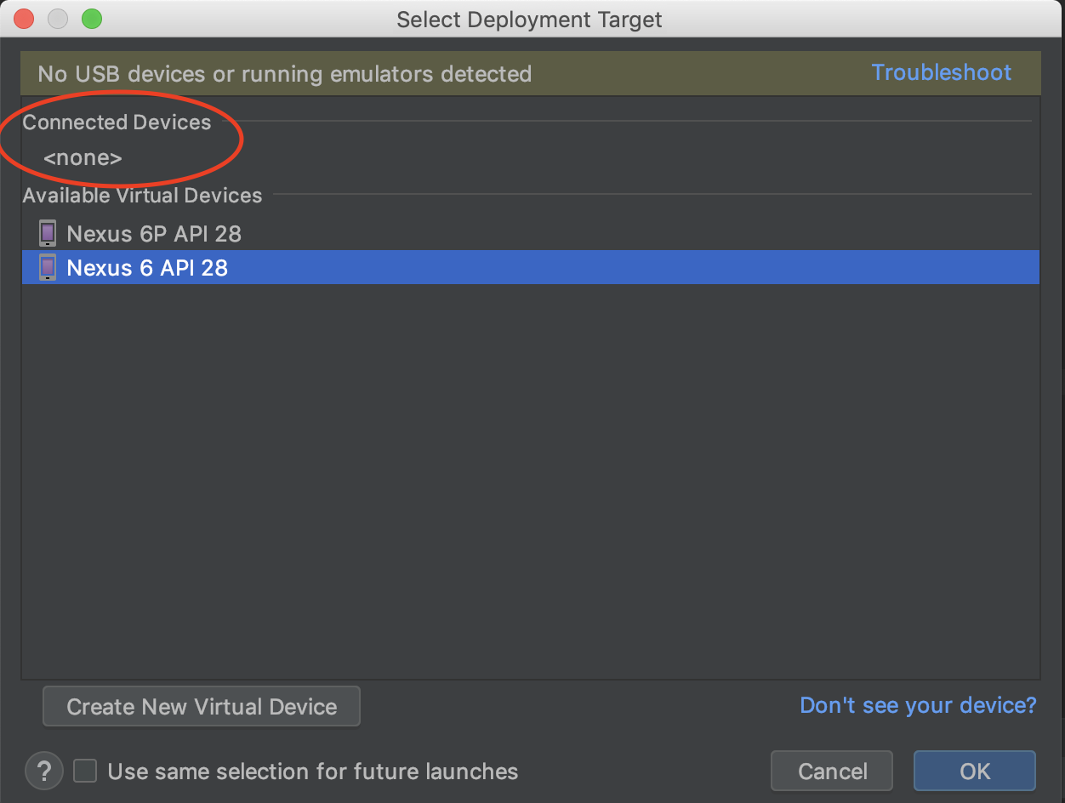

Figure 28. Select connected device to run the code

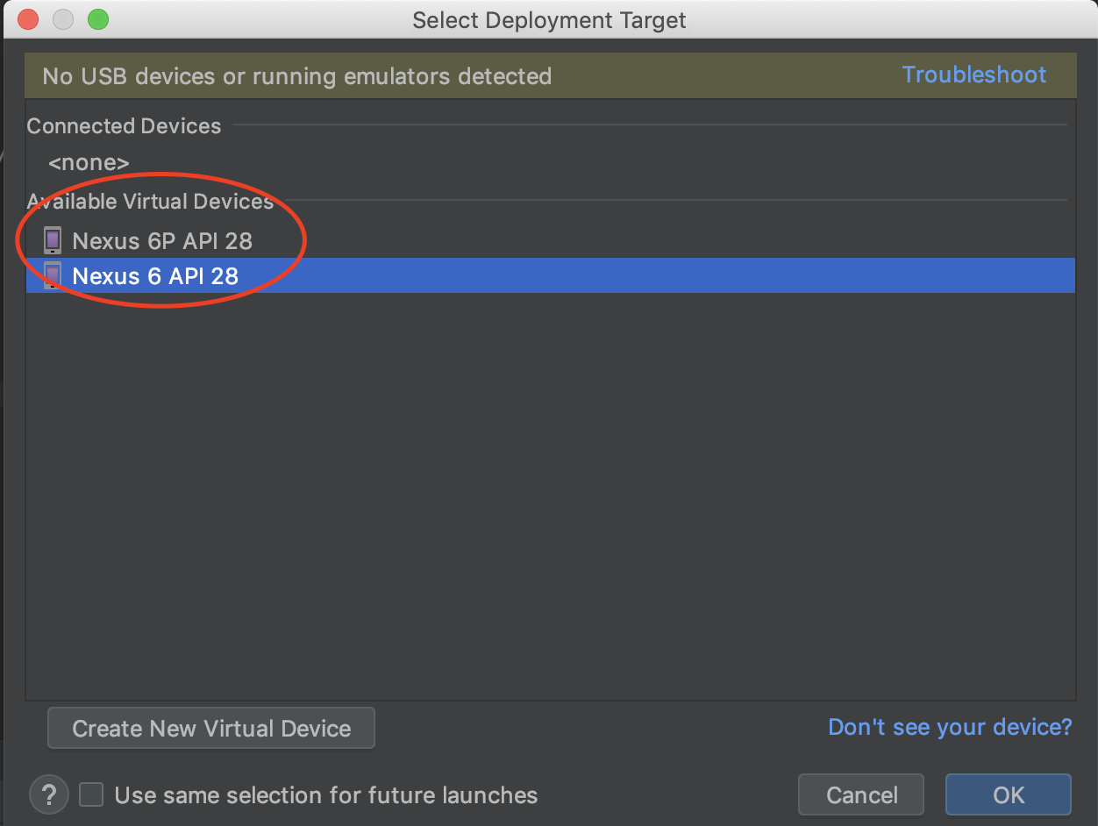

Figure 29. Select virtual device created to run the code

# **Guidance on operating the server-side**

This part of the manual documents how the administrator (Admin) shall use and manage the server-side of the system. Firstly, we want to talk about the architecture of the app using figure 30, which illustrates perfectly the architecture of the Kinder Food Finder system. Firstly, consumers who goes shopping for animal-based products can access information about ethical brands, find location, and inform others where to find a particular good using the mobile application; In turn, depends on the commands given by the end-users, the mobile app will choose to display information or interact with the web server through HTTP connection. Likewise, the server side of the Kinder Food Finder system was developed in the format of a Web application; In short, by accessing to the server using browser and HTTP URL, a web page will be displayed to the administrator and grants him/ or her full control over the data in the database (Which directly impacts the data that the server sends to the Kinder Food Finder app).

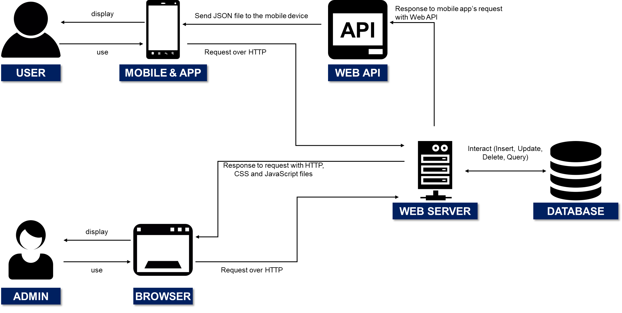

*Figure 30. Architecture of the Kinder Food Finder system*

In short, the server-side will **control the information displayed** in the mobile application. Hence, the next section will discuss in detail on how you should operate the server, including login, insert new data, update and delete data, and generate statistical data (demographic data of end-users: How many times a brand is searched, filtered by age, timeline and gender).

## **Login to the Server-side**

Firstly, you should open the default web browser in your PC and type the following URL address: <http://localhost:3000>. The web browser will automatically display the web-page server landing page (Refer to figure 31). Hence, enter the following **default** username and password to access the server: Username – **admin**, Password - **admin**; Please be advised that, the username and password can be changed later. Upon login into the server, you will see a page identical to figure 32.

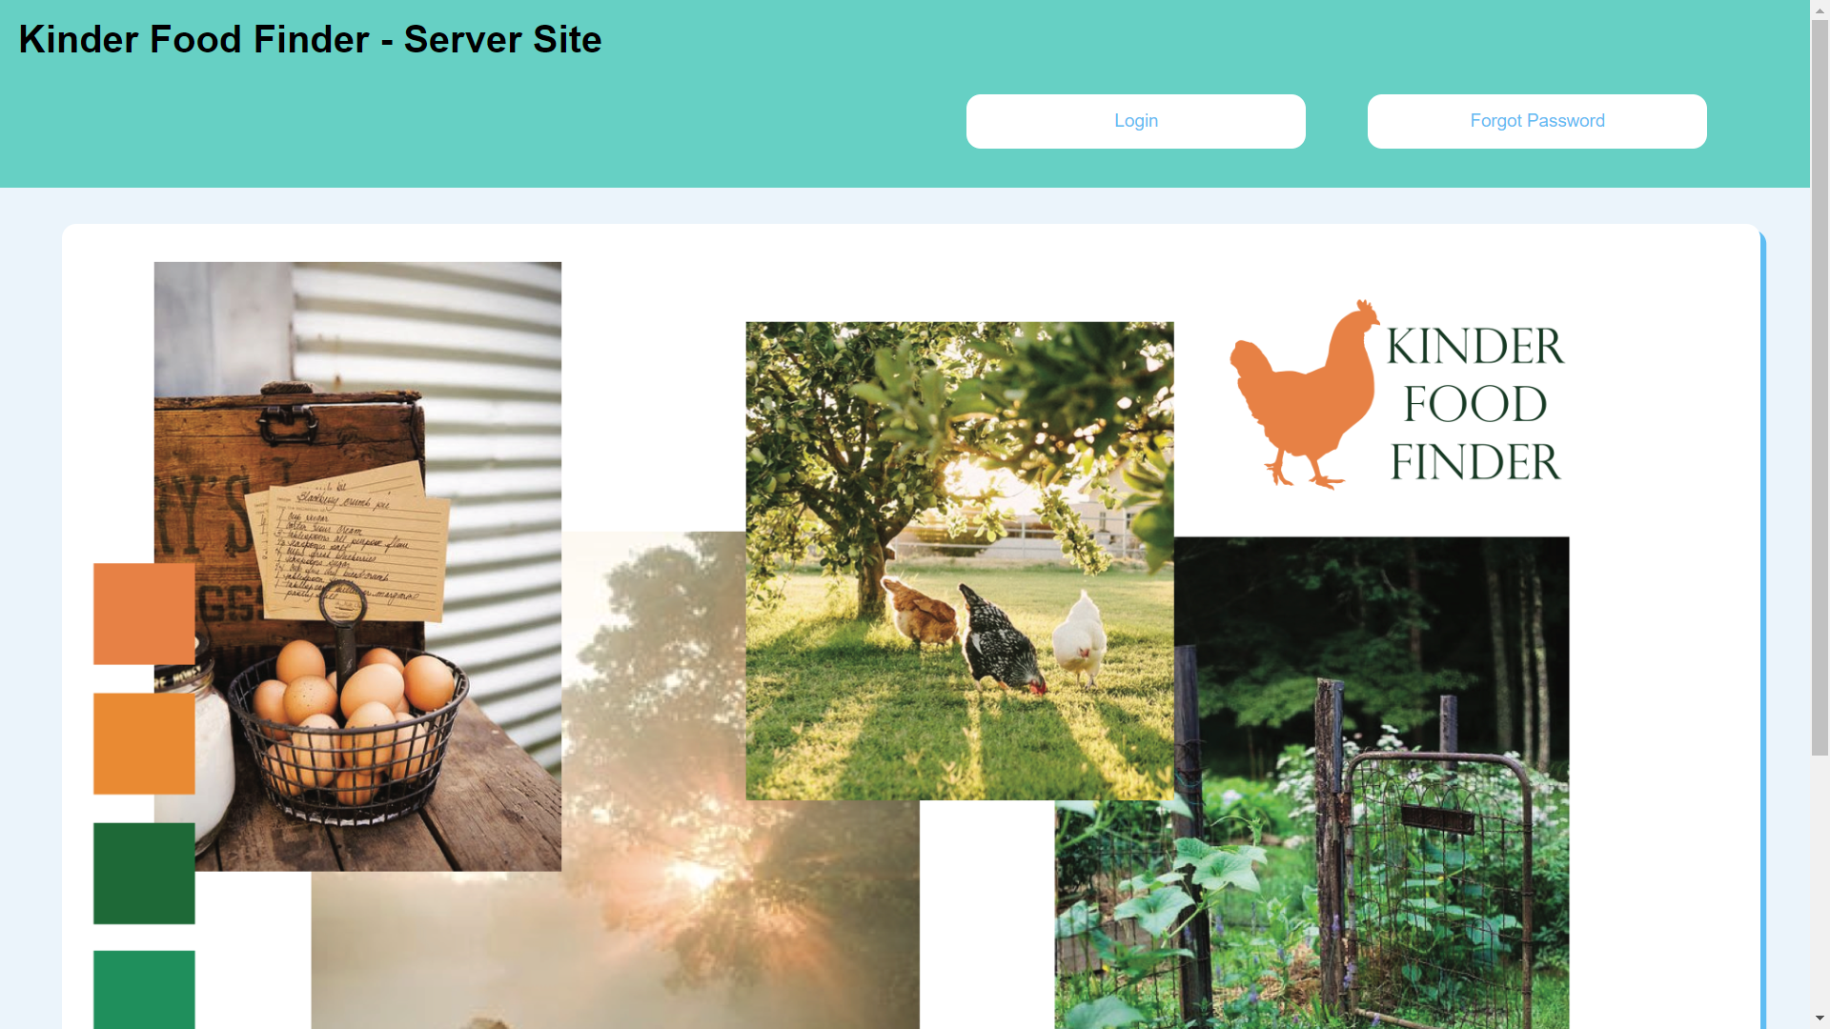

*Figure 31. Landing page of the web-page server*

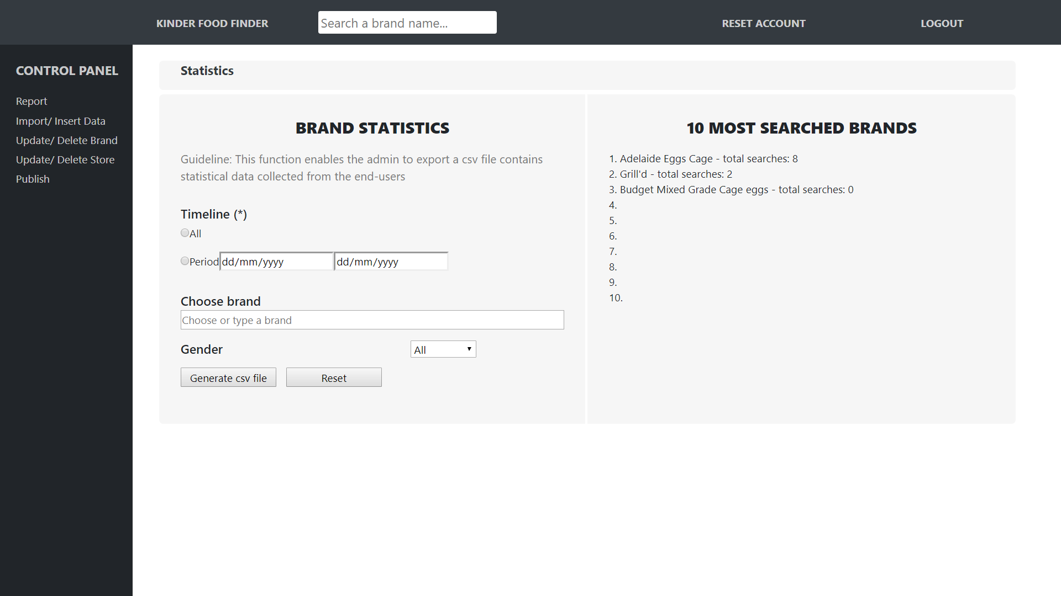

*Figure 32. Home page/ statistics page*

To help the administrator access to every feature on the server conveniently, the layout is built with a control panel tab of the left side and a navigation bar on the top; Hence, by clicking on the different buttons, you will be able to access other functions (For instance: Import/ Insert data, report, update/ delete brand):

* Report: This feature allows the admin to view report on where to find different brands from the end-users. In this view, the admin can choose to delete or add the report to the database so other users will know where to find a particular brand.
* Import/ Insert data: This feature allows the admin to import brand data (Brand name, accreditation and rating) from a csv files, or insert a brand/ or store using the input box provided on the web-page server.
* Update/ Delete Brand data: This feature enables the admin to delete a brand from the database. Furthermore, the admin can also access the “Brand detail page” from this view to update a particular brand (Add image, change name, add more accreditation and rating).
* Update/ Delete Store data: This feature enables the admin to delete a store from the database. Furthermore, the admin can also access the “store detail page” from this view to update a particular store (Add address, change name, add or remove product from the store).
* Publish: Publish the new version of the database (Brand database and store database to the mobile application)
* Reset account: This feature allows the admin to change the account’s username and password after login.

## **Import/ Insert data**

As mentioned above, this function allows the admin to import data from a csv file or insert one brand/ store using the input boxes provided on the web-page server. Upon going to this view, you will see a drop-down list that asks for the type of data to insert (Refer to figure 33).

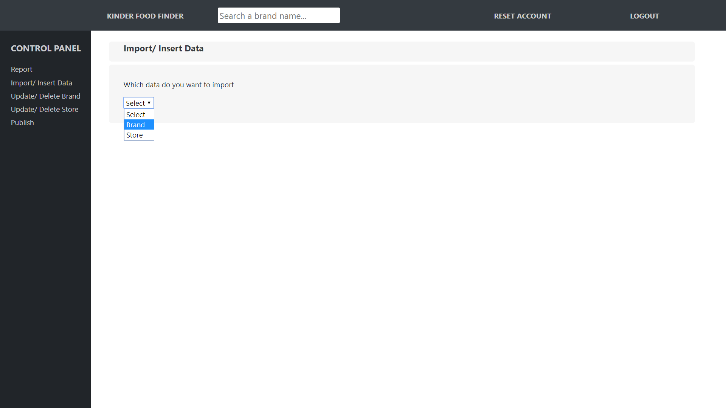

*Figure 33. Import/ Insert Data*

1. **Import/ Insert brand data**

Upon choosing to input brand data to the database, the “Import/ insert brand data” view will be displayed to you (Refer to figure 34). On the left of the view, the admin can click on the button “Choose File” to choose the **CSV** file that consists of data about multiple brands (Brand name, accreditation, rating); After that, the admin can click on the “Upload file” button and the server will automatically process that file to import data to the database. Likewise, on the right-side of the view, the admin can choose to insert one brand to the database by filling multiple input boxes (This feature can insert only one data at a time, while the import csv file allows the admin to insert more than one data at a time).

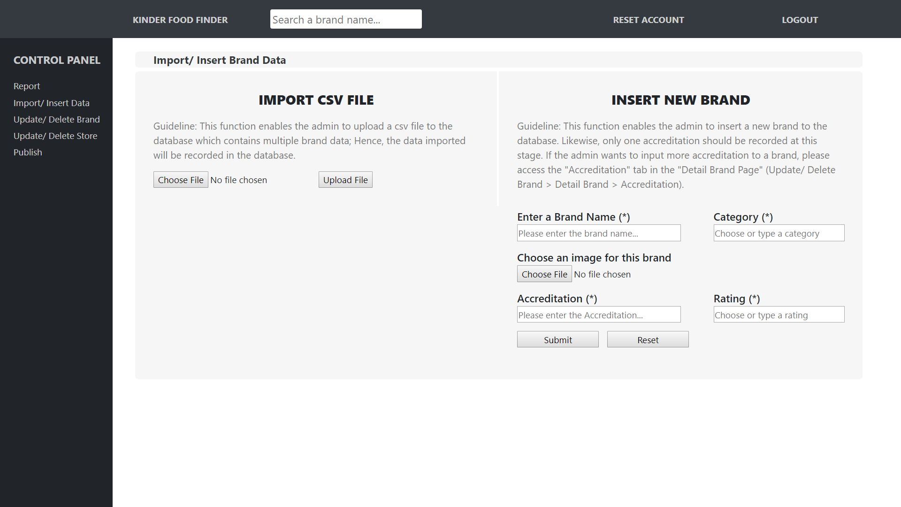

*Figure 34. Import/ Insert Brand Data*

1. **Insert store data**

Figure 35 displays the layout of the insert store data feature; Hence, to insert data, you should fill in all required input boxes on the right-side of the layout. Upon clicking the submit button, the server will process the address that you just insert and compare it with **real** address in the country; After processing the input data, a window will appear that enable you to choose from a list of address (Refer to figure 2). Please be advised that, the feature is designed this way to ensure that: (1) The address is accurate in context of the real world, (2) The server will automatically process the address to obtain the longitude and latitude (Geographical location) of the system, which will be used by the mobile app (Locate function). Lastly, due to the complexity and ad-hoc nature of the import csv function, we decided to remove the “Import store csv file” in the server-side.

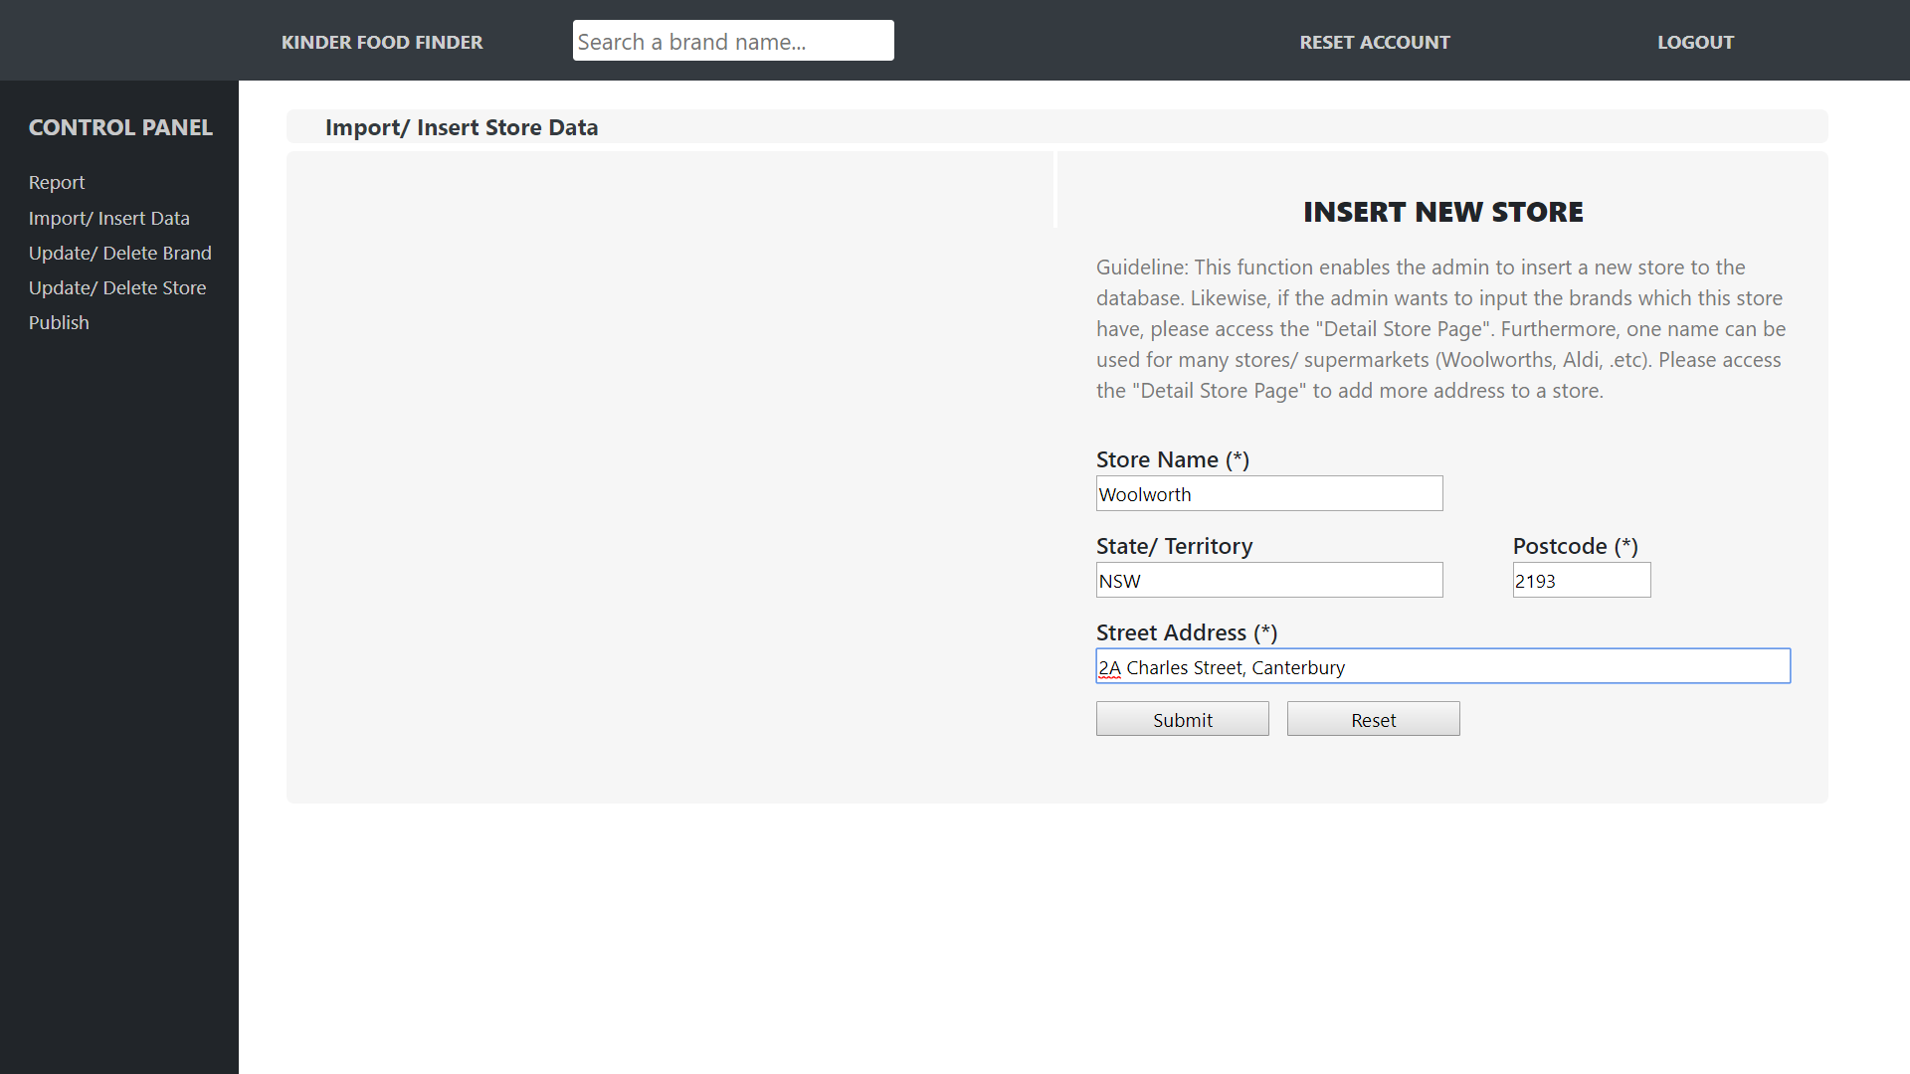

*Figure 35. Insert store data (1)*

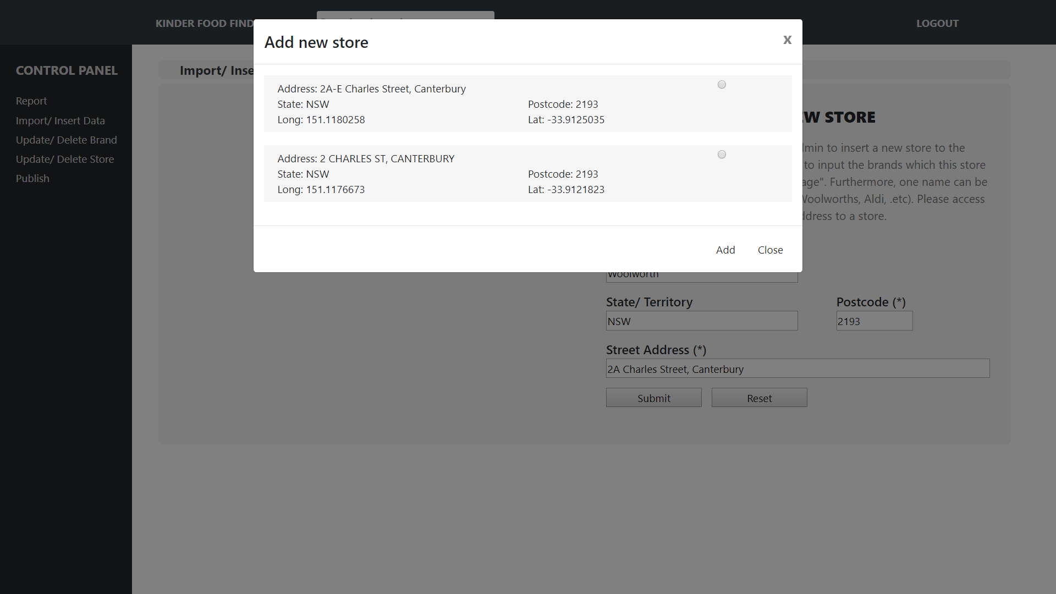

*Figure 36. Insert store data (2)*

## **Update/ delete brand data**

Upon going to the “Import/ Delete Brand data” feature, the server will display a table that contains all available brand in the database (Refer to figure 37). Hence, to delete a brand, you can check on the delete box of the brand you want to delete on the right-side. Please be noticed that, deleting a brand will also delete related connections that the brand involves in. For instance, in case the database currently records that “Adelaide Eggs Cage” can be found in “Woolworth – 2A Charles Street, Canterbury, 2193, NSW”; By deleting “Adelaide Eggs Cage”, the connection between that brand and “Woolworth – 2A Charles Street, Canterbury, 2193, NSW” will also be removed (This feature is designed this way to ensure that the database is consistent and connection between different factors is available only when those factors exist. Having a connection without the required factors will result in ambiguous data displayed to the administrator). Furthermore, in case you want to update a brand, click on the **brand name** and the server will automatically direct you to the “Brand detail page”.

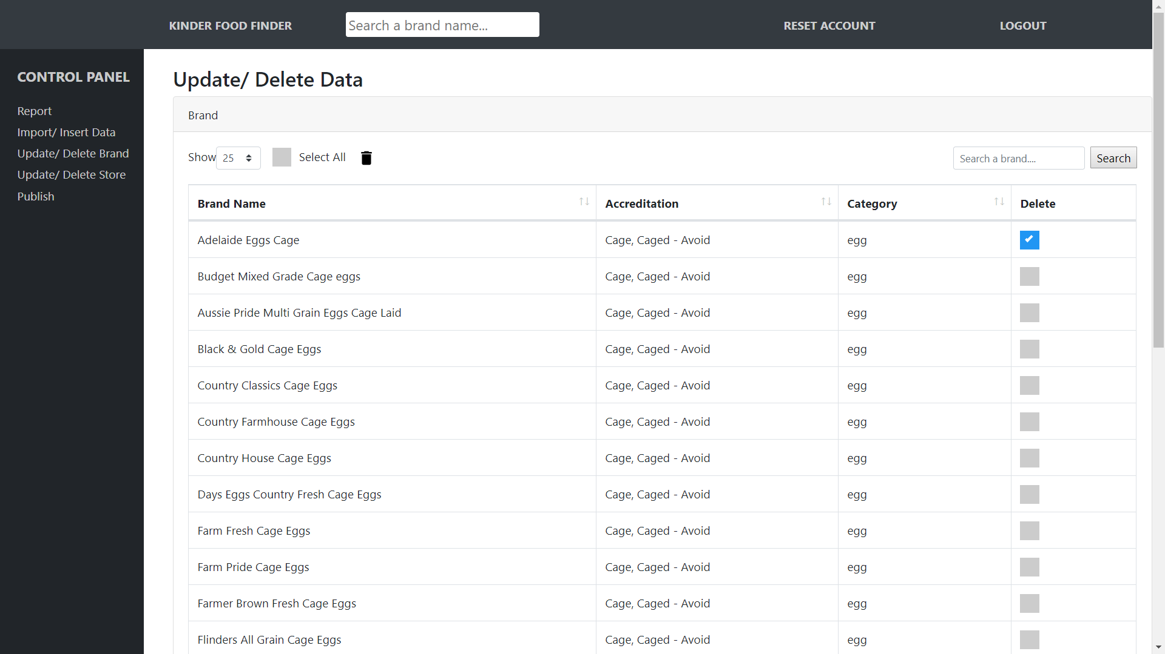

*Figure 37. Update/ Delete brand data*

1. **Detail brand page – Brand summary**

This feature enables you to update the (1) Name of a brand, (2) Category and (3) Image of the brand. Please be advised that the system only allows one image per brand due to the limitation in mobile application storage (The app will download the image and save it to the local database of the smart device; Hence, when user searches for a brand, the app will display that image to user. Likewise, an image file is heavy and having heavy sized files in a smart device is not the best practice in mobile computing).

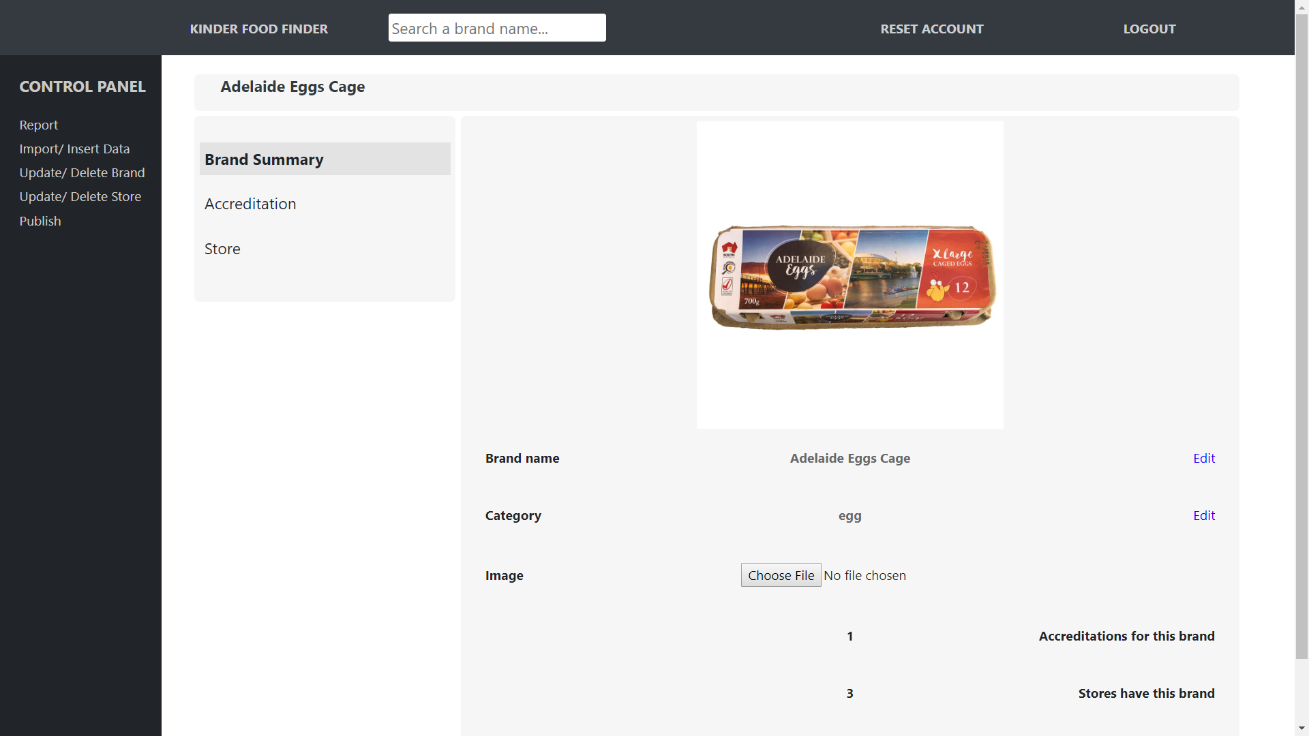*Figure 38. Detail brand page – Brand summary*

1. **Detail brand page – Accreditation**

The Accreditation page displays accreditation and corresponding rating that a brand has. This feature enables the system to store and display **multiple accreditations** for a brand. Furthermore, the admin can delete or add more accreditations to a brand using this feature. To add new accreditation, you shall click on the “Plus” button (Button with the “+” sign) and a new window will pop up enables you to enter the new accreditation (Figure 39)

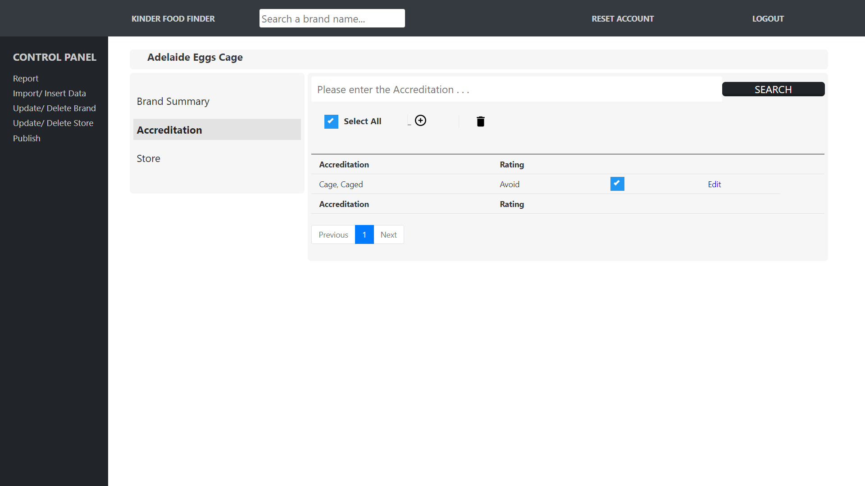

*Figure 39. Detail Brand Page – Accreditation (1)*

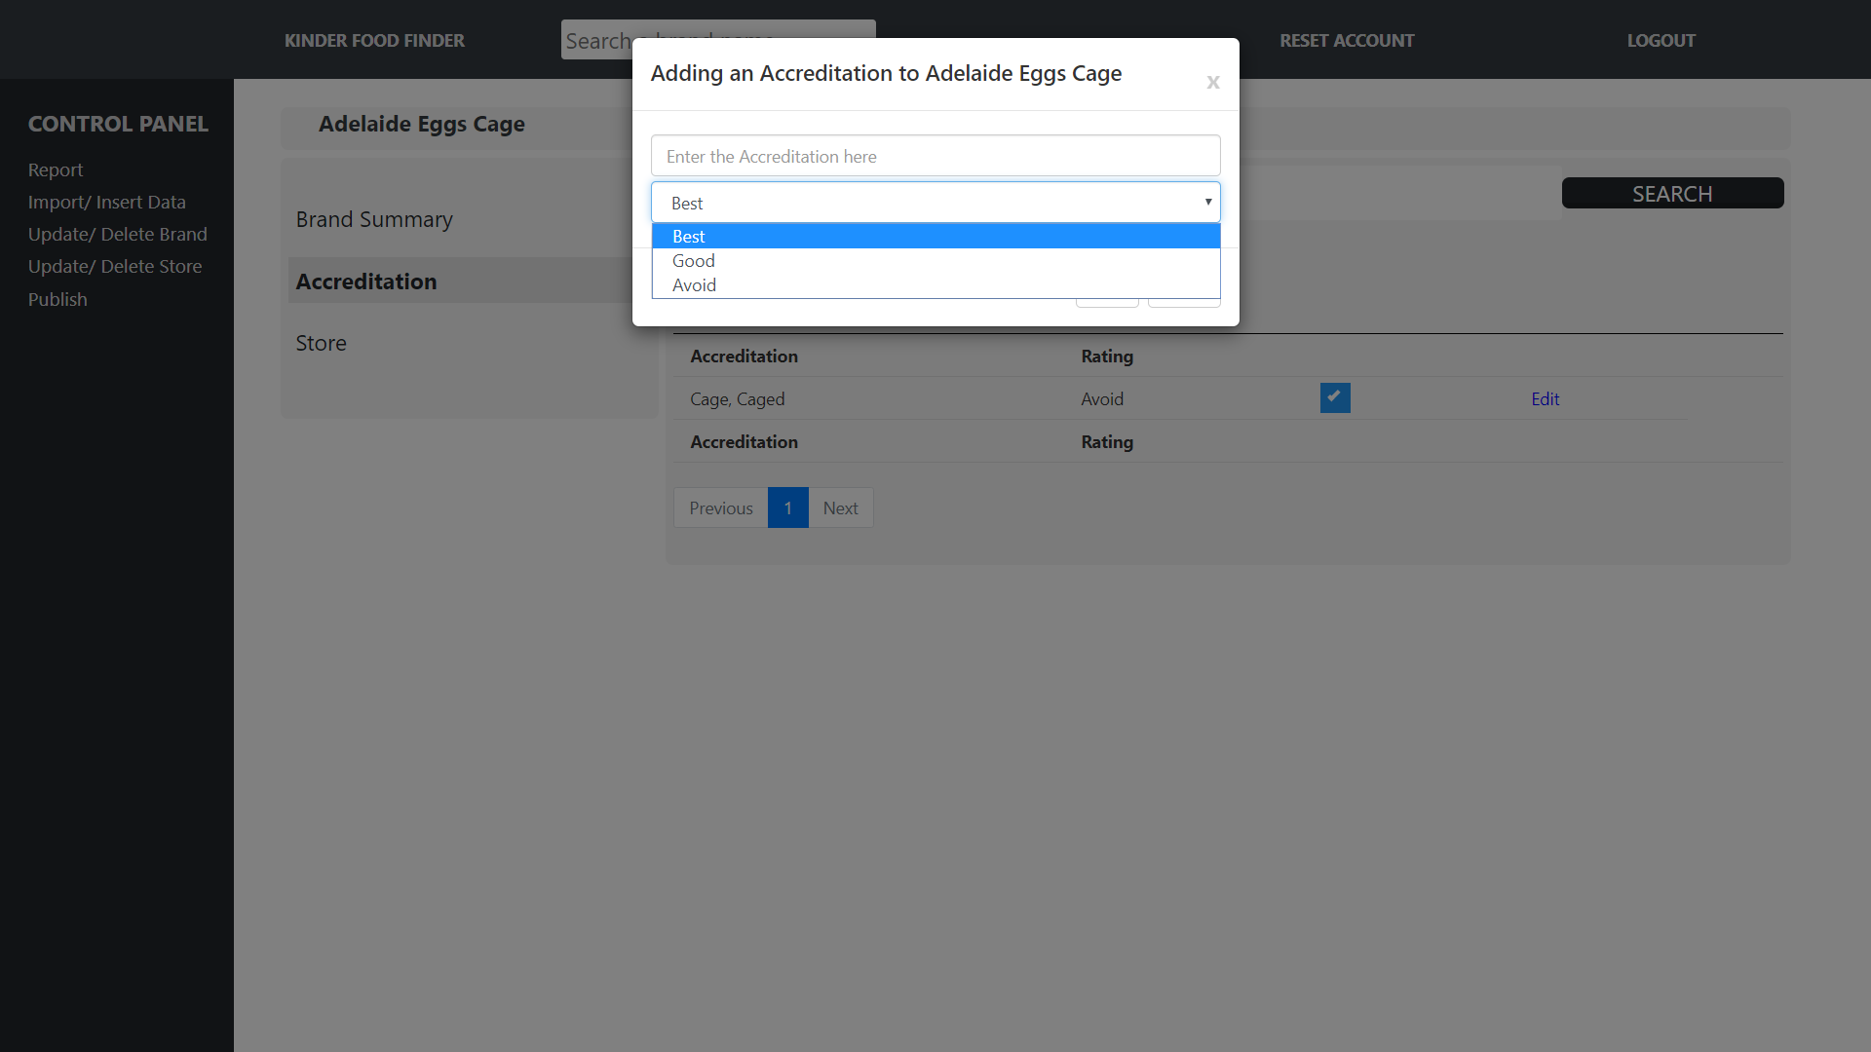

*Figure 40. Detail Brand Page – Accreditation (2)*

1. **Detail brand page – Store**

This feature enables the administrator to identify which store and address is selling the brand and delete the connection between that brand and the store. However, this feature does not allow the user to create a connection between brand and store; to create the connection between these factors, please access the “Detail store page – Address”.

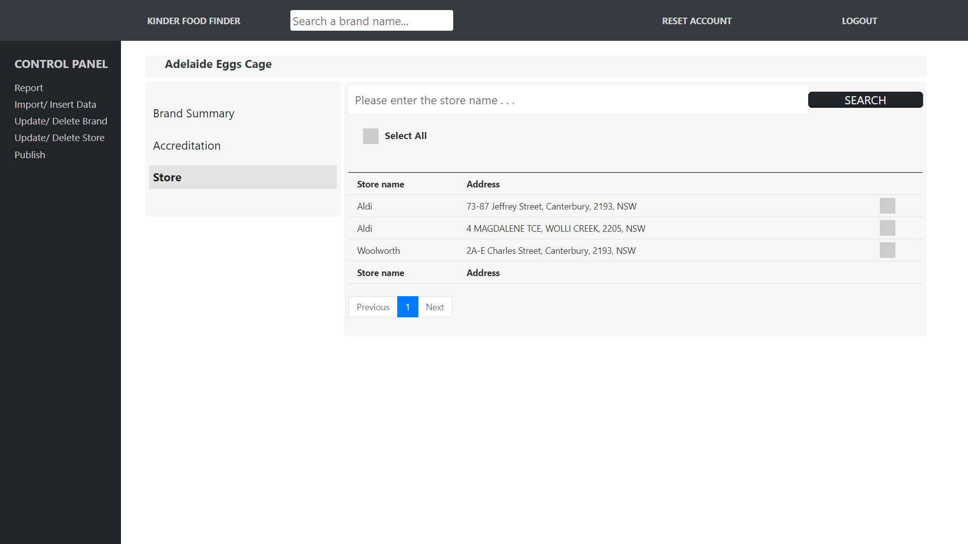

*Figure 41. Detail Brand Page – Store*

## **Update/ delete store data**

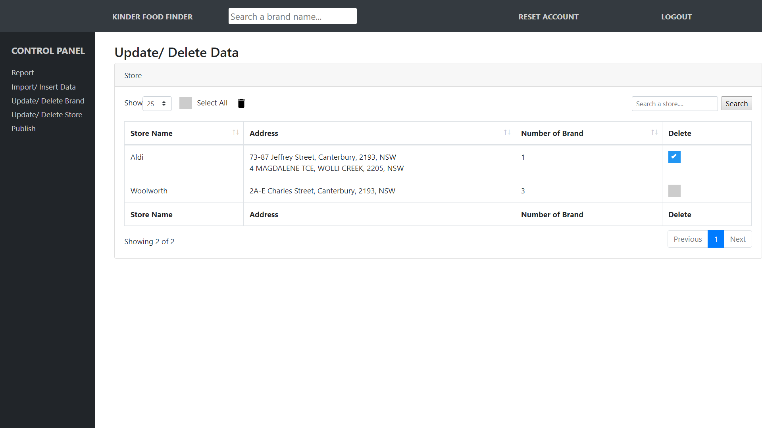

*Figure 42. Update/ Delete Store data*

Similar to the Update/ Delete Brand data, this feature displays all the store available in the database, addresses and the number of brands that the store has. Furthermore, the feature also allows the admin to delete or update information of a store. Lastly, by clicking on the store name, you will go to the “Detail store page”. Please be advised that, deleting a store will remove any connections between that store and the brands which that store has.

1. **Detail store page – Store Summary**

This feature enables the admin to change the name of the store and displays information about the number of addresses and brands that the store has.

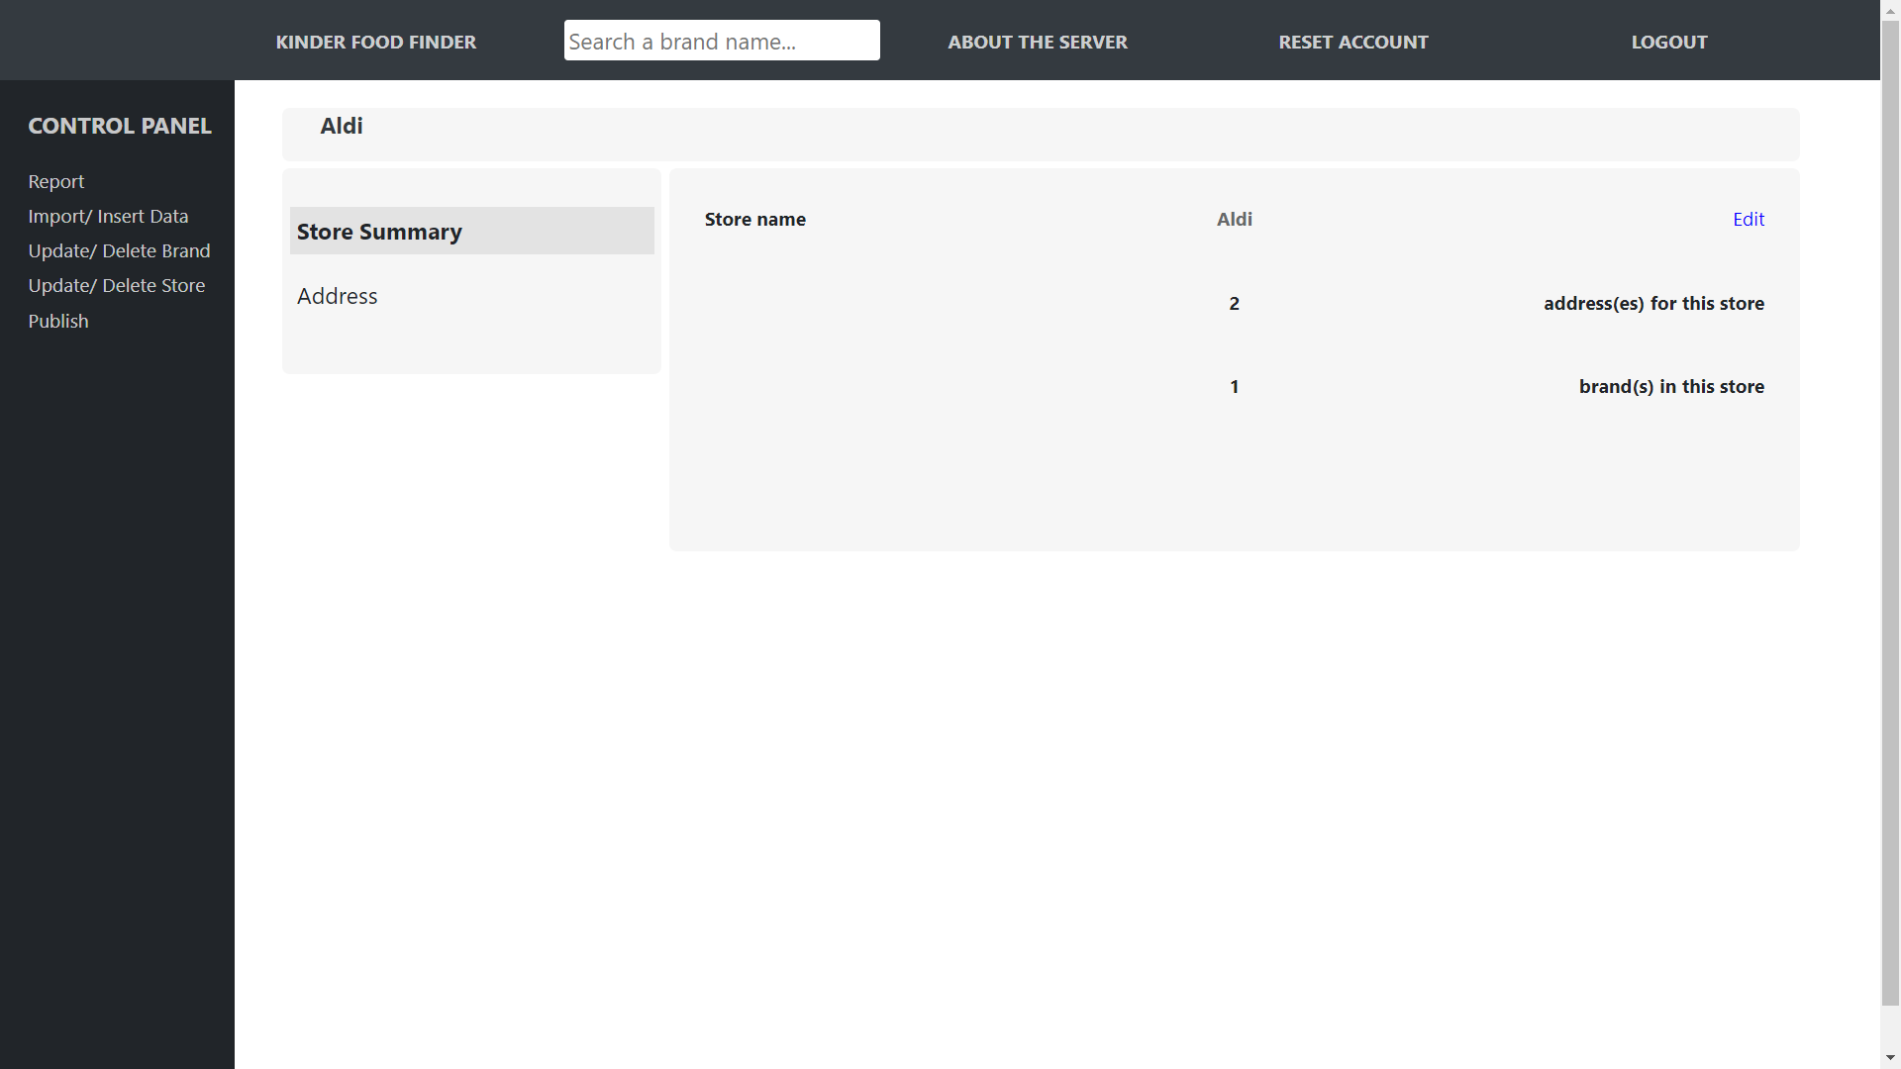

*Figure 43. Detail store page – Store Summary*

1. **Detail store page – Address**

This feature displays all the addresses that a store has; For instance, Woolworth will have several infrastructures all over the country. Furthermore, you can choose to delete or add new address to the database using the delete checkbox on the right-handed side or the “Plus” button on the top side of the layout (Figure 44). In addition, by clicking on an address, the server will direct the admin to the “Detail store page – brand”.

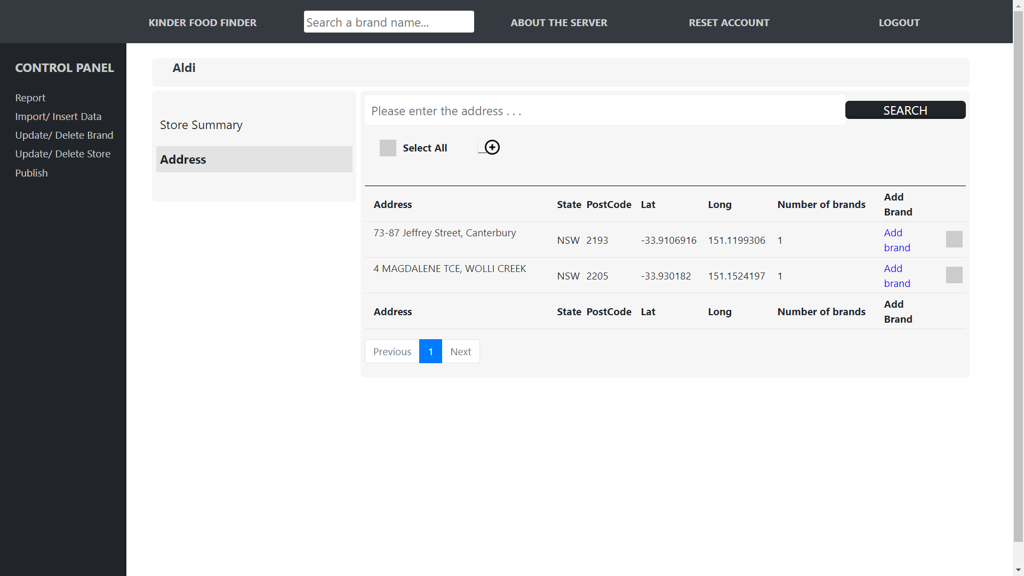

*Figure 44. Detail store page – Address (1)*

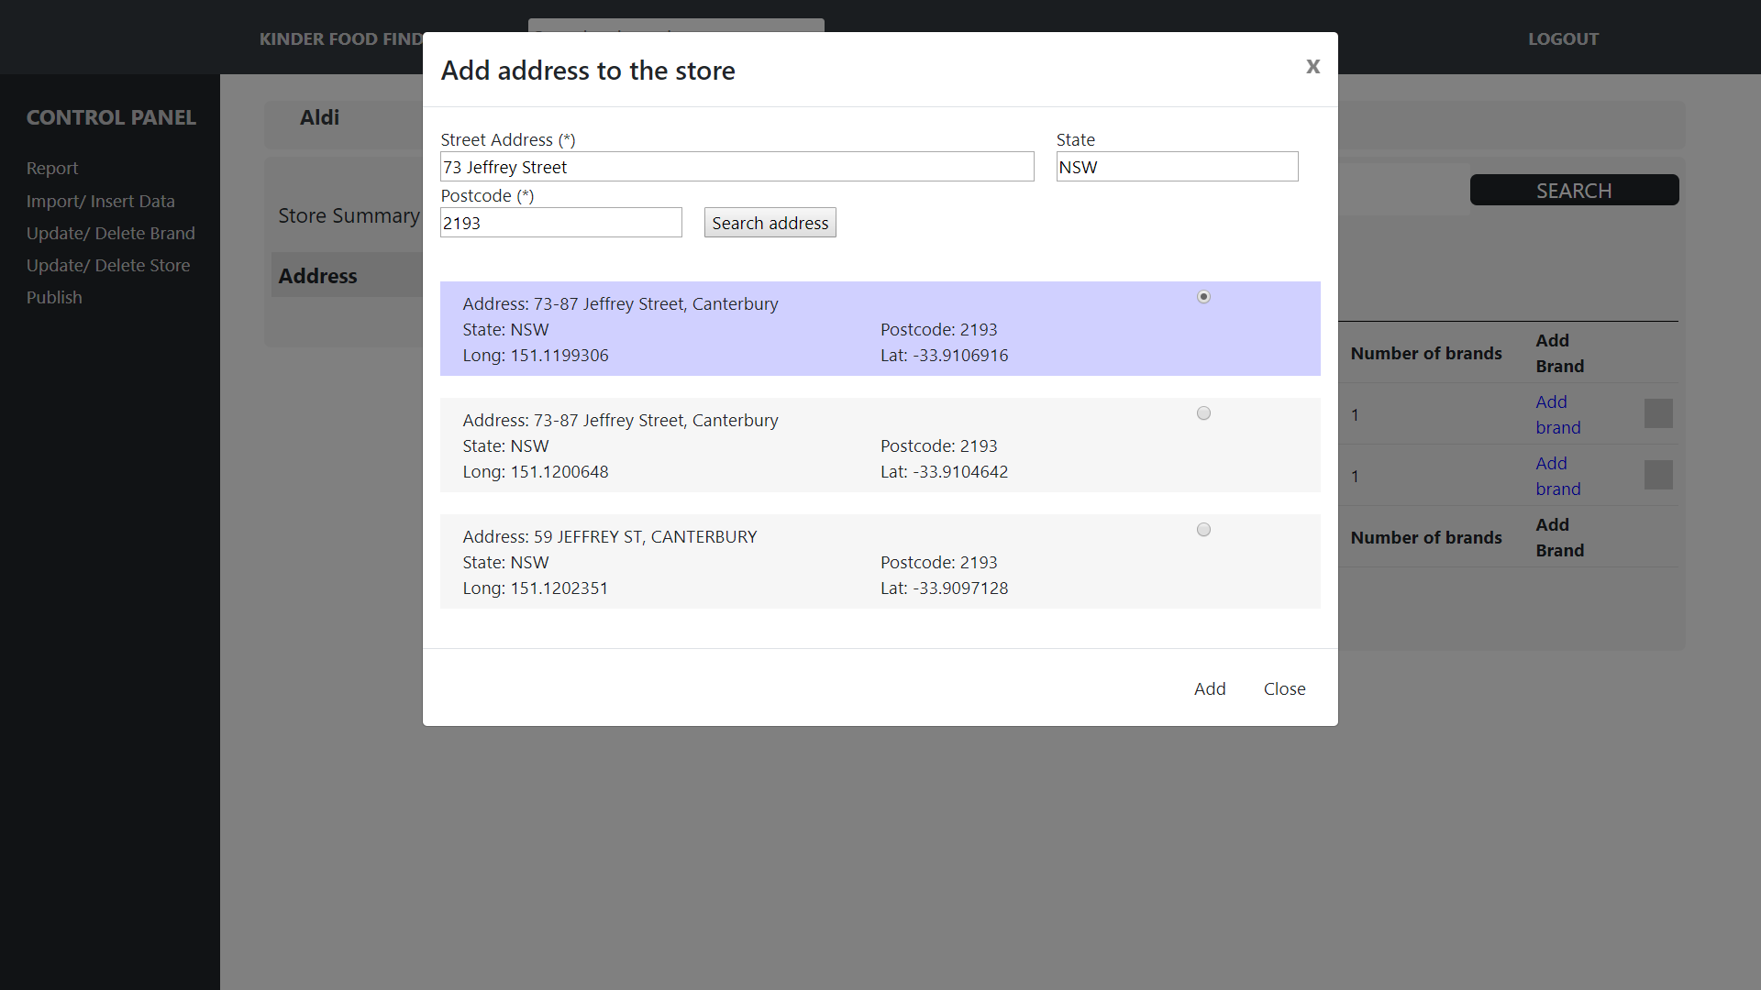

*Figure 45. Detail store page – Address (2)*

Likewise, you can also add connection between a brand and store address using the “Add brand” button (There are two approaches that the admin can use to create connection between brand and store address, this is one of the two approaches; We will mention another approach in the **Report** section). Upon clicking on the “Add brand button”, a new window will appear that displays all brands that the store address **does not have** (After you added a connection and reset the page, the brand you just added will be removed from this list)**.**

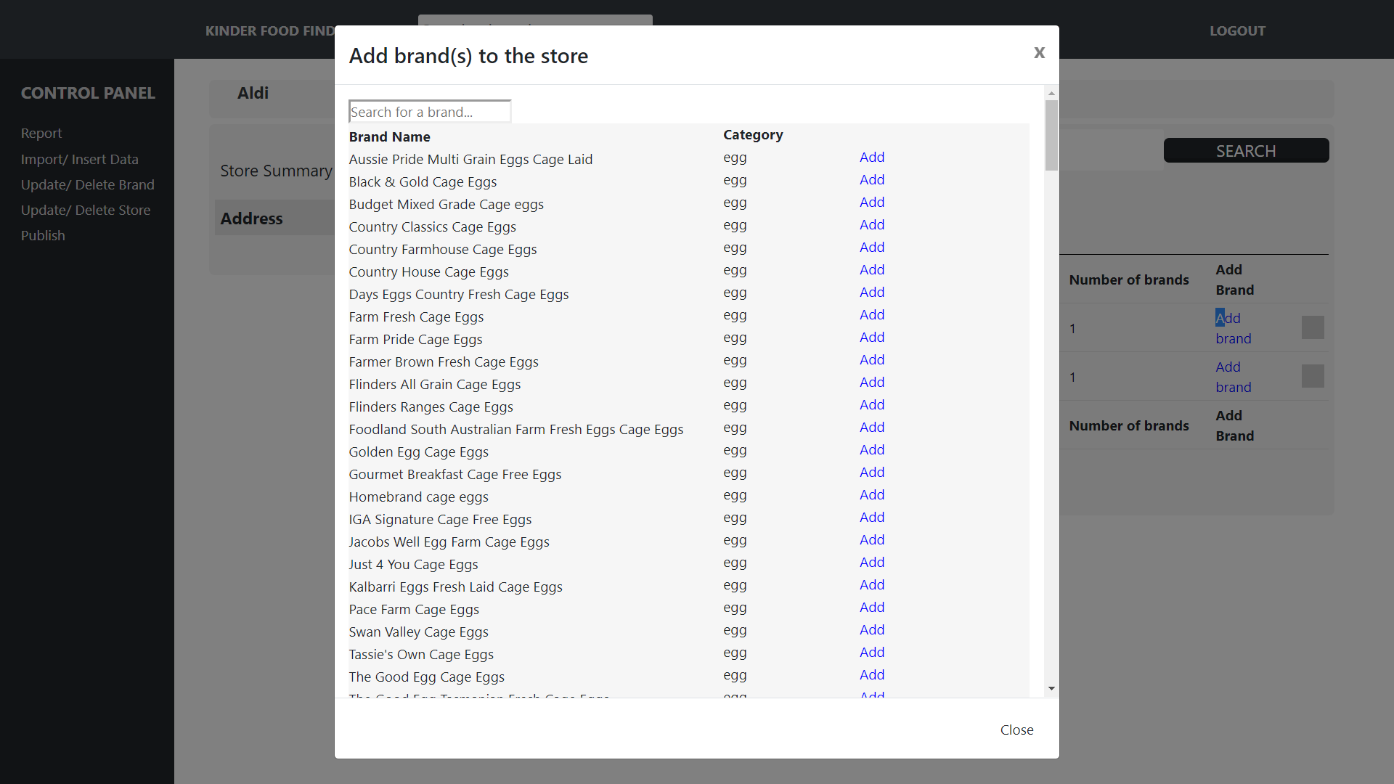

*Figure 46. Detail store page – Address (3)*

1. **Detail store page – brand**

This layout displays all brands that a store address has. Furthermore, it also enables you to delete or add more connection between brands and store address to the database using the delete checkbox on the right-handed side and the “Plus” button on the top side of the layout.

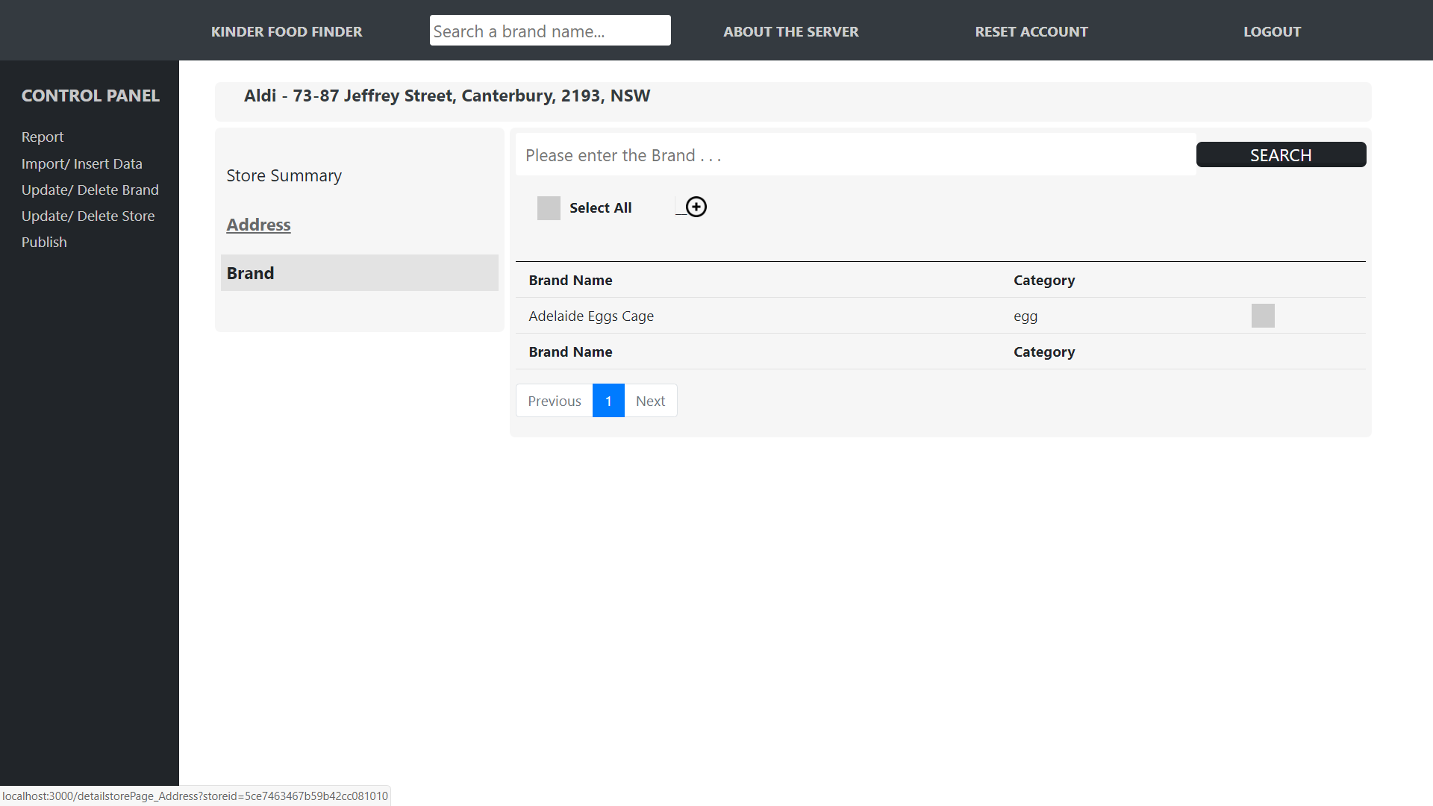

*Figure 47. Detail store page – Brand (1)*

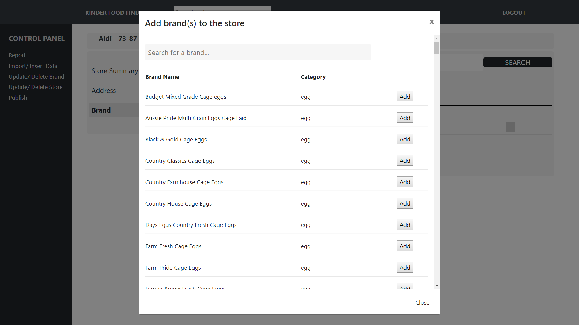

*Figure 48. Detail store page – Brand (2)*

## **Report**

This feature records reports from mobile app users about which store address has a brand. For instance, when a mobile app user report where they find “Adelaide Eggs Cage”, his/ or her report will be sent to the server and recorded in this feature; The administrator can choose to delete the report or approve it and add the information to the database (Be noticed that this is the second feature that helps create connection between a brand and store address). Hence, by clicking on the “Add report” button, a new window will appear that lets you choose the correct address from a list of addresses (Similar to the insert store data).

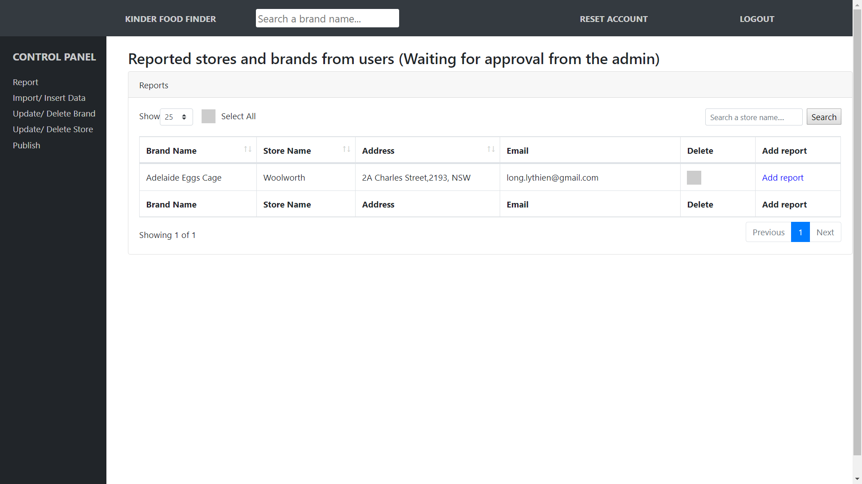

*Figure 49. Report page (1)*

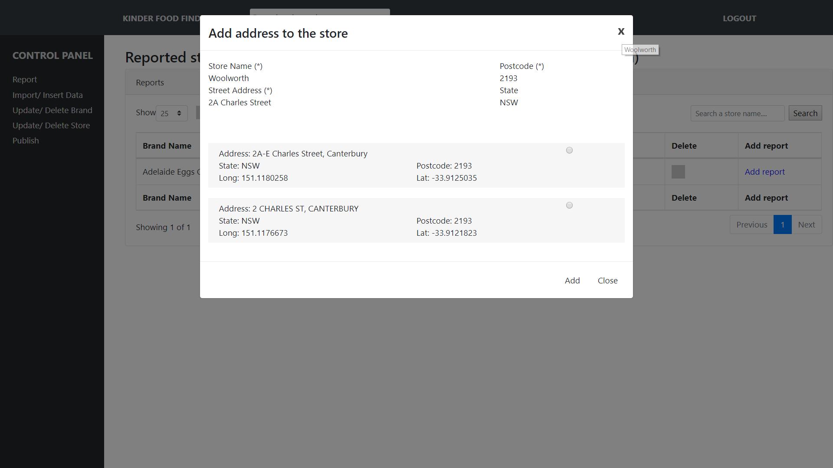

*Figure 50. Report page (2)*

## **Publish**

Upon adding, deleting, updating data in the database, to ensure that the mobile application could receive the most updated version of the database, the admin should use this feature to publish information.

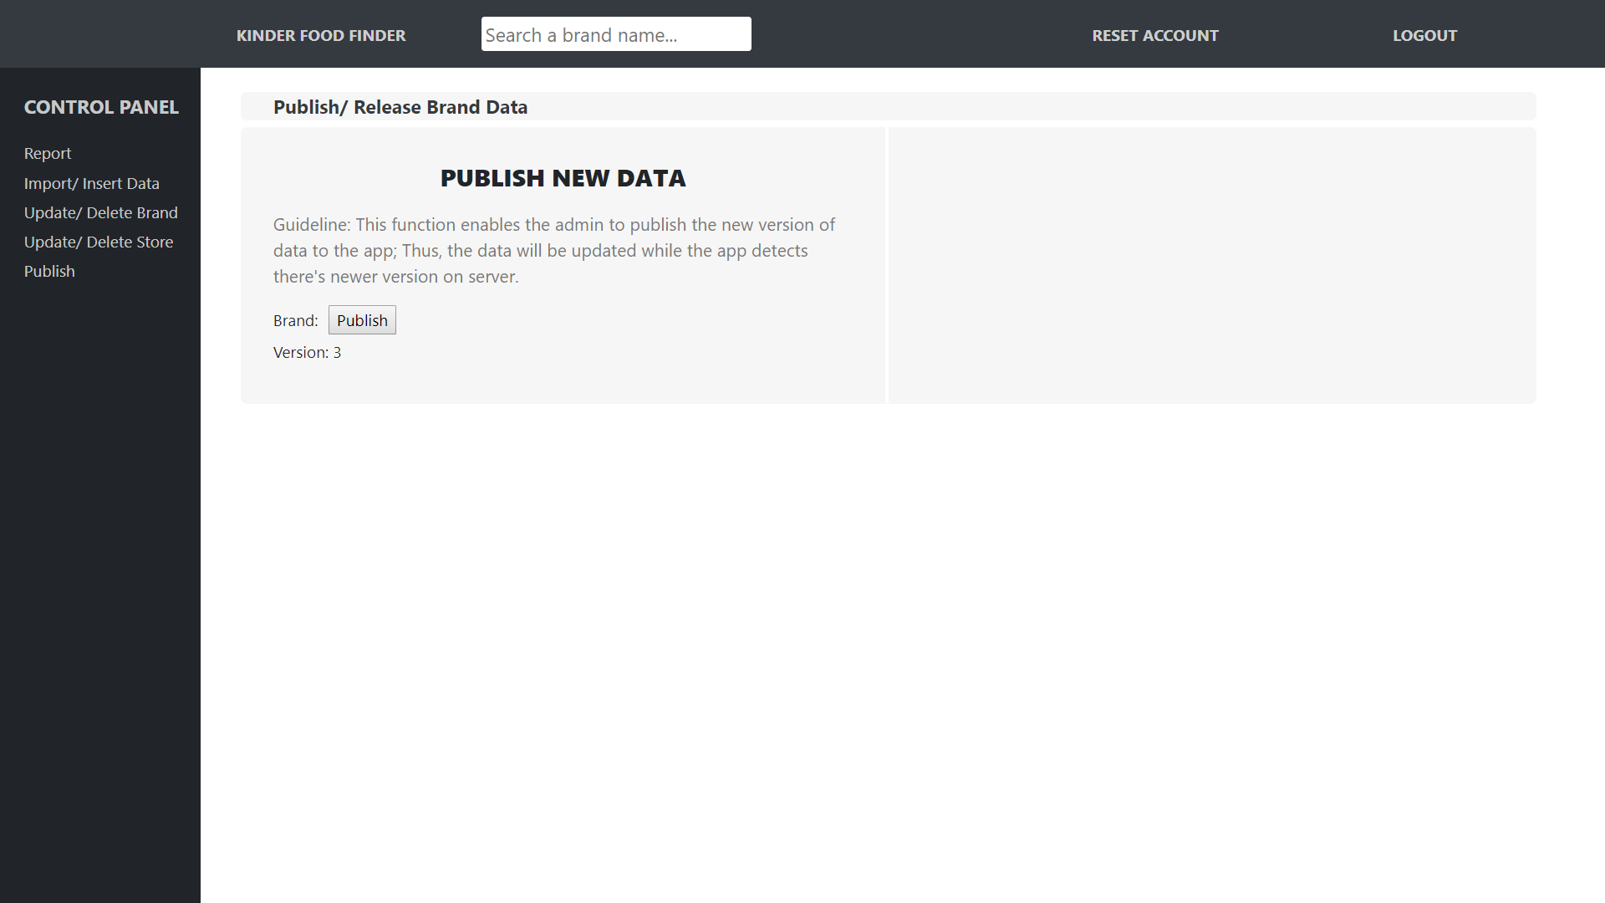

*Figure 51. Publish page*

## **Statistics**

This feature enables the admin to generate a CSV file that contains statistical data collected from mobile application users (Number of times a brand is searched by gender, age and timeline). In specific, by filling all the required input boxes on the left-handed side of the layout and click “Generate csv file” button, the browser will automatically download a statistical file (Refer to figure 52). In specific, the Timeline section enables the admin to choose the timeline of the data that will be generated, the admin can choose to generate data from all the time using the “All” button or data from a particular time range by defining the start date and end date of the timeline; Likewise, the Brand section allows you to choose to generate statistical data of all the brands available or just one specific brand in the database. Lastly, the gender enables you to choose which gender the statistics file should have.



*Figure 53. Statistics page*

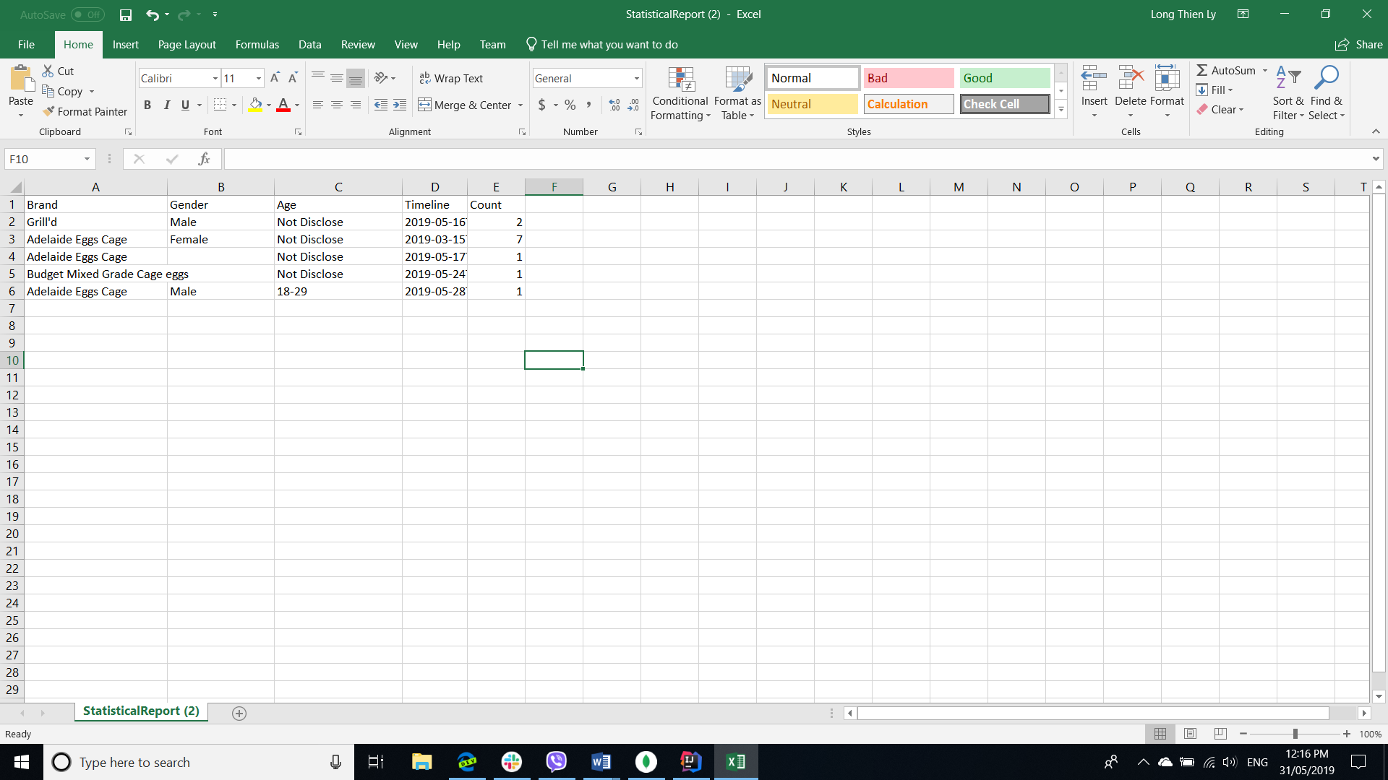

*Figure 54. Statistics file*